Elif Sebnem Cudi

Tresham Lesson Schedule

COMP4 Project

Contents

1. Introduction 3

1.1 Project Background 3

1.2 Project Aims and Objectives 3

1.3 Project Development Methodology 4

2. Requirements Engineering 5

2.1 Elicitation Activities 5

*2.1.1* *Interview* 5

*2.1.2* *Survey* 8

*2.1.3* *Other problem domain research* 14

2.2 Requirements Specification 15

*2.2.1* *Problem Domain Description* 15

*2.2.2* *Functional Requirements* 17

*2.2.3* *Performance Requirements* 18

*2.2.4* *Design Constraints* 19

*2.2.5* *Commercial Constraints* 19

3. System Analysis & Design 20

3.1 Preliminary Design Stages 20

*3.1.1* *Textual Analysis* 20

*3.1.2* *Significant Event Analysis* 20

*3.1.3* *Commands and Queries* 21

3.2 Detailed Static System Designs 22

*3.2.1* *First Draft BON System Architecture Diagram* 22

*3.2.2* *BON Class Charts* 24

4. System Interface Designs 27

4.1 Draft Interface Designs 27

*4.1.1* *Wireframes* 27

*4.1.2* *System Navigation Diagram* 35

*4.1.3* *System Screen mock-ups* 36

*4.1.4* *System Activity Event Diagrams* 43

4.2 Database Design 48

*4.2.1* *ERD* 48

*4.2.2* *Data Dictionary* 49

*4.2.3* *Queries* 51

*4.2.4* *Reliability* 52

5. Build report 53

5.1 Database 53

5.2 Website 64

6. Testing 85

6.1 Alpha testing plans 85

*6.1.1* *Input and output* 85

*6.1.2* *Links* 88

*6.1.3* *Form* 89

6.2 Alpha testing 90

*6.2.1* *Input and output* 90

*6.2.2* *Links* 93

*6.2.3* *Form* 94

*6.2.4* *Testing Outcome Screenshots* 94

6.3 Beta testing plans 117

*6.3.1* *Student UI* 117

*6.3.2* *Teacher UI* 118

6.4 Beta testing 119

*6.4.1* *Student UI* 119

*6.4.2* *Teacher UI* 120

7. Documentation 121

7.1 User Manual 121

8. Evaluation 122

8.1 Comparison of Project Performance against Objectives 122

8.2 Future Development 123

8.3 User Feedback 124

# Introduction

## Project Background

The second year A Level students of Tresham College usually study 3 different A2 subjects. At the beginning of the academic year, students are given an empty timetable on A4 paper, and as they apply for their course on the enrolment day, they write down the day, time, room and teacher of their lessons on the paper given. Throughout the year, if they lose the paper, they can ask for a new copy of the empty timetable to refill, make their own, or use the dedicated board on the second floor that shows the timetables for different subjects.   
The teachers on the other hand, use a service called Pro-Solution: an integrated student management and information system. This service -as well as showing student details, grades, and disciplinary records- shows an in-depth timetable to the teacher. It also has a room booking system. However, not all teachers bother with the booking process, meaning that there are many misunderstandings with who is meant to be teaching in which room, and consequently there are frequent room changes.  
There are also problems with students finding classrooms, particularly for the first 2-3 months of the academic year. It is difficult for new students to remember the location of their usual classroom, let alone find the allocated classroom when there is a room change.  
The above problems cause delays in learning - the communication between teachers and students outside class is very poor.  
Tresham has a VLE (Virtual Learning Environment), but the forums are rarely used, and when they are, it is used for help and advice on the subject, rather than notices like classroom changes or a simple “homework due in”.

## Project Aims and Objectives

I want to simplify the way students and teachers view their timetables, and the way room changes, teacher absences, homework etc. are communicated. I will create a bespoke website unique to the students and teachers of Tresham. This website will be an abstraction of a timetable; displaying not a full week, but a single day’s schedule, depending on the day picked by the user. The users will be able to see the time, subject, teacher and room of the lesson, as well as any notices put by the teacher. Users will also be able to view the location of a classroom on a floor map. Teachers will additionally be able add, modify or delete notices.

Objectives:   
1. The website should be connected to a database.  
2. The database should have information on student and teacher login details, course details, lesson details, and room locations.  
3. The website should authorise logins only from the students and teachers that have records in the database.  
4. The student and teacher versions of the website should vary: teachers should have an extra link for the notice modification page.  
5. Only teachers should be allowed access to the notice modification page.  
6. The main schedule should have a dropdown list of days in order, for user to select.  
7. Once a day is selected, the schedule should list every lesson the user has on that particular day, ordered by the time.  
8. For a single lesson, the schedule should list the time, the course name, the teacher name (for students’ schedule only), the room number, and the notice (if there is one).  
9. The room location page should have a dropdown list of rooms, with room numbers extracted in order from the database, for user to select.  
10. Once a room number is selected, the room location page then should display an image of the location of the classroom on a floor map.  
11. The notice modification page should only display information for the subjects the teacher who is logged in teaches.   
12. The page should list the course name, the day of the lesson, the time of the lesson, the room of the lesson, and the current notice for the lesson. However, the teacher should only be able to make changes to the notice.  
13. The user should be able to logout at any time.  
14. The UI dimensions should be coded in %, so it can be tablet and smart phone friendly.  
15. The website must have a minimalistic design, so it is simple and to the point, as well as tablet and smart phone friendly.

## Project Development Methodology

I will be using the Waterfall Methodology, consisting of the stages:

1. Analysis  
 2. Design  
 3. Implementation  
 4. Testing and Integration  
 5. Deployment

As the full featured application must be delivered by a given deadline.

# Requirements Engineering

## Elicitation Activities

For the elicitation activities of the project I will be interviewing Gilbert Moore, head of the Humanities department. I will also create an online survey for students to fill in.

### *Interview*

#### Interview plans

I have decided to interview Mr. Moore because he has been a teacher at my college for a number of years and is averagely computer literate.

|  |  |
| --- | --- |
| Question | Reason |
| What is the existing system for communicating with students outside of class? - Things like room changes, time changes, homework deadlines, etc. | This question is to get an idea of how teachers communicate with the students, or at least what they think is meant to be happening. |
| What are the benefits of the current system? | This question is to see why the current system works and is an argument against creating a new system. |
| What are the drawbacks of the current system? | This question is to get information on what the proposed system could include in order to be used by more teachers. |
| What’s the existing system you use to check your timetable? | This question is to see what the teachers currently use. |
| What are the benefits of the system you use? | This question is to see why the current system works and is an argument against creating a new system. |
| What are the drawbacks of the system you use? | This question is to get information on what the proposed system could include in order to be used by more teachers. |
| Do you think the college would benefit from a bespoke schedule system | This question is the main factor that decides whether the proposed system will be a solution to the current problems. |

#### Interview findings

**What is the existing system for communicating with students outside of class? - Things like room changes, time changes, homework deadlines, etc.**If the change is long term, the change is sanctioned by management and Head of School or deputy changes the official time table.  
If the change is short term, the students are told in a previous lesson or as soon as possible by whatever means is most appropriate. Often the PDC uses their mobile phone and emails the students with the new information or he or an administrator rings the student at their contact number to let them know.  
We have a cover system for staff and they may pass on a message such as a room change or leave a note on the door pointing to the new venue.   
  
**What are the benefits of the current system?**  
It is approved. We have children as well as adult students and this system is seen as safer. At university an announcement is made (and an automatic email sent) and that is about it. We cannot rely on a child reading such so we don't.  
  
**What are the drawbacks of the current system?**  
For adults it can be patronising. We do not have a substantive record of short term or ad hoc changes that the announcement system would provide.  
  
**What’s the existing system you use to check your timetable?**  
Staff usually has a paper printout in colour on their desk board (I personally have an Excel spreadsheet version on my PC as well). The official version is on Pro-solution where registers are found.  
  
**What are the benefits of the system you use?**  
It is my own version so probably up to date. The official version may well have "lag".  
  
**What are the drawbacks of the system you use?**  
It is not digital so gets messy over time with annotations until I "update" it. It is geographically centric i.e. you have to come into the staff room to see the printout!  
  
**Do you think the college would benefit from a bespoke schedule system?**  
Yes. 

In response to Mr. Moore’s answers:   
- There is a problem with the teachers’ system being geographically centric. This includes their digital version of the timetable as well, as most teachers do not carry their laptops around with them. The physical copy, like Mr. Moore said, can have a messy look to it, if the teacher is not willing to update and reprint every time a change happens to it.  
- Very short term changes could be taken note of with a simple post-it note, but if the teacher’s desk is unorganised, it has a chance of getting lost.  
- Mr. Moore mentioned the PDCs using their mobile phone and emailing the students, however, most of the time this is not the case. I personally have only received emails from the Head of 6th Form (and this was only once) about lesson changes. The PDC only contacts me in regards to her own lessons. This shows me that how the teacher thinks the notices are handled is a little different from reality, and therefore is a communication problem.

### *Survey*

#### Survey plans

I will create an online survey as students tend to find physical surveys boring and time consuming. It’s a lot easier to gather data by online means.   
I will be using the website surveymonkey.com to create the survey as this service allows me to summarise the results in a graph form.  
I will send the link to 40 A2 students, with picking at least 1 student from each A2 subjects offered.

|  |  |
| --- | --- |
| Question | Reason |
| How often do you forget your timetable? 1/2/3/4/5 (Never – Sometimes – Always) | This question is to see how often the students need a reminder of their schedule. |
| Do you have a physical copy of your timetable? Y/N | This question is to see whether the students depend on physical or electronic copies. It also checks who has lost their timetable and who haven’t. |
| Do you use an already-existing system (e.g. mobile application, Microsoft Excel) to view your timetable? Y/N | This question is to check whether it’s worth building an online system for students to use. |
| How often do you use the dedicated timetable board? 1/2/3/4/5 (Never – Sometimes – Always) | This question is to see whether the dedicated timetable board serves its purpose and is not there just for decoration. |
| Do you use an already-existing system (e.g. mobile application, planner) to note things like room changes or homework? Y/N | This question is to see whether students keep a record of lesson changes. |
| How often do you receive notifications about lesson changes? 1/2/3/4/5 (Never – Sometimes – Always) | This question is to see how frequent the lesson changes are communicated, as the students might not be getting notified every single change. |
| Is making a better way of communicating with teachers about lesson changes necessary? 1/2/3/4/5 (No – Maybe – Yes) | This question is the main factor that decides whether the proposed system will be a solution to any communication problems. |

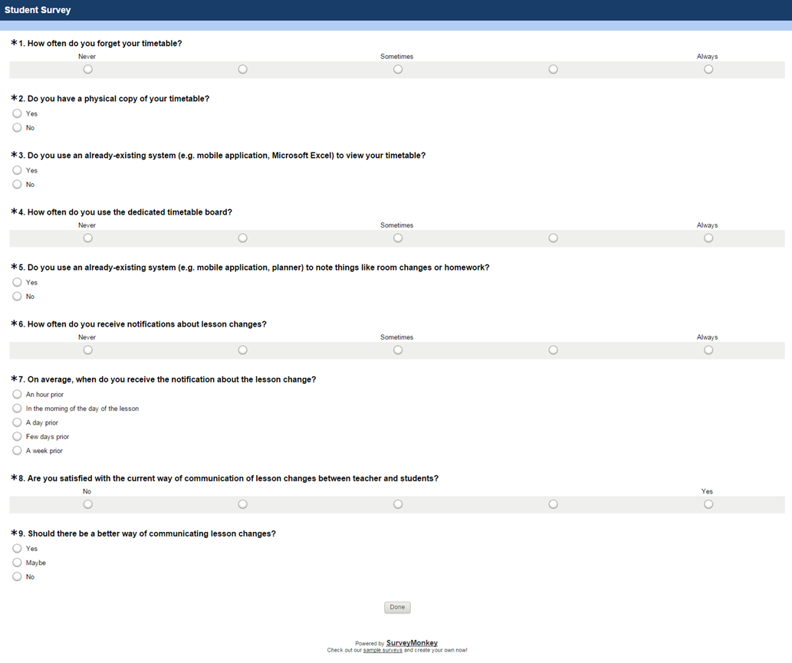The view of the online survey:

#### Survey findings

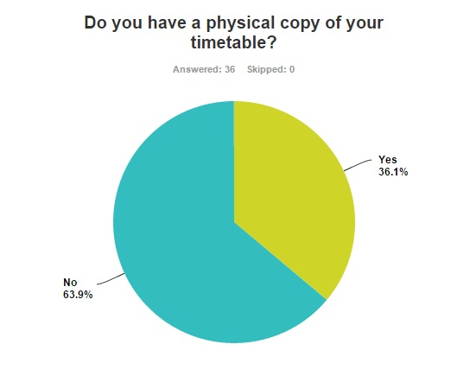  
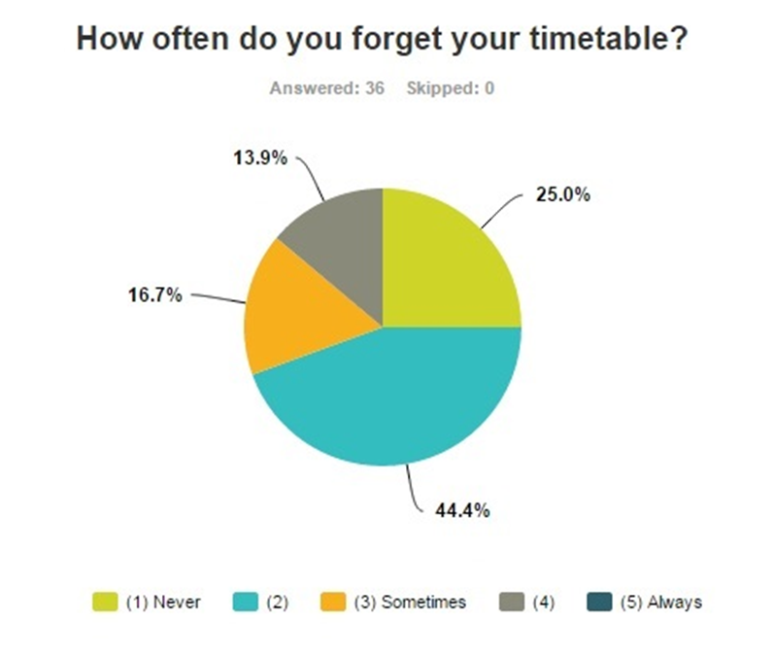

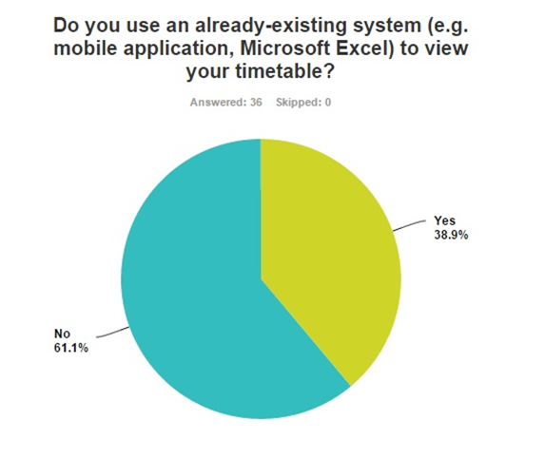

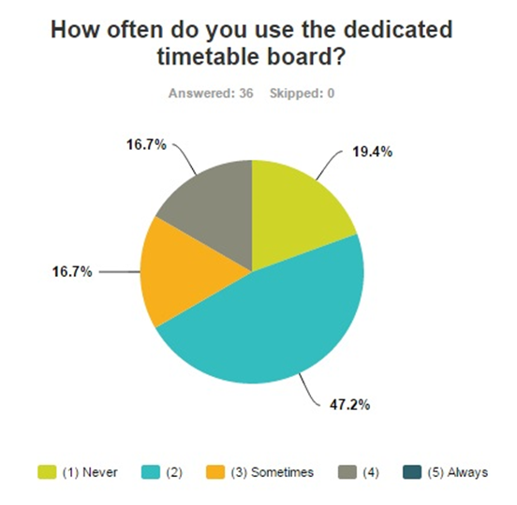

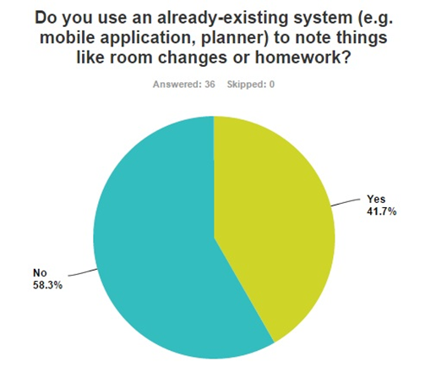

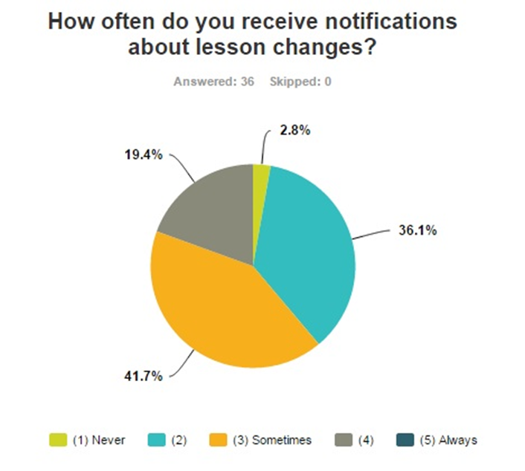

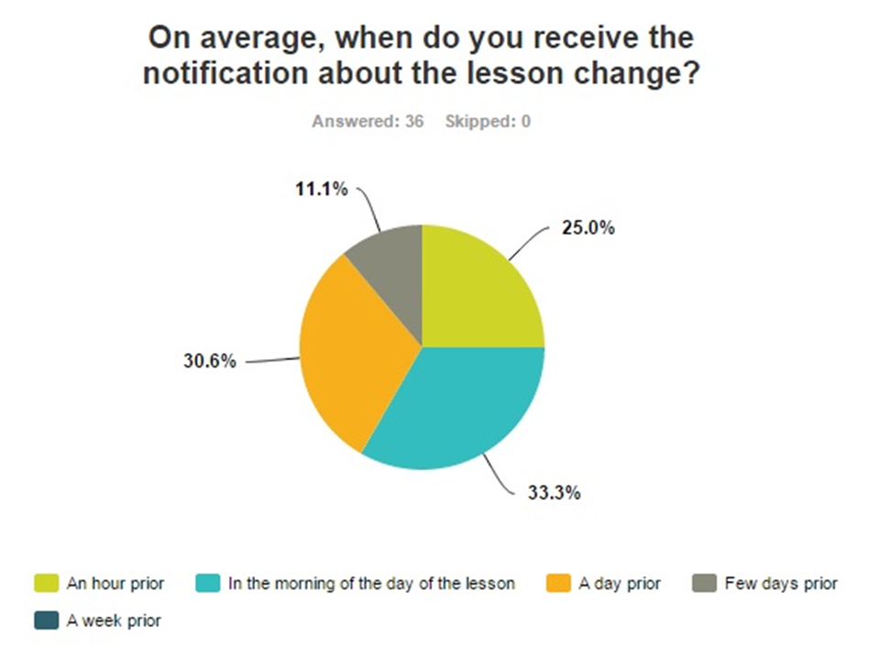

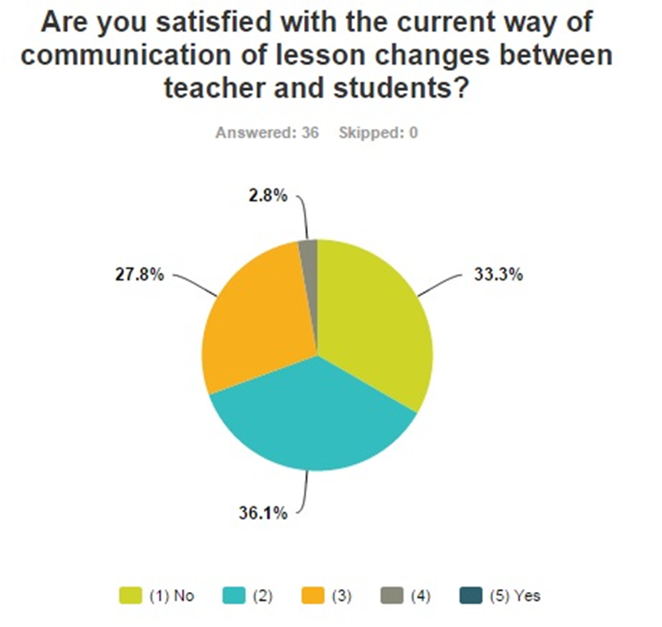

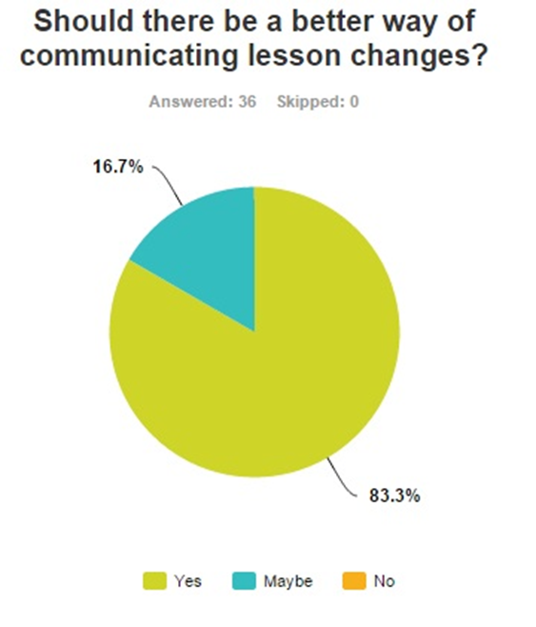

### *Other problem domain research*

#### Comparable Software System Review

Mobile applications (e.g. “Timetable”, “Class Timetable”, and “My Study Life”): these require users to enter information about their timetable, and then display them in a day or a week form. These also allow users to add notes like lesson changes or homework. On android devices, these applications usually have widgets too, which allows users to have their schedule shown on their homepage. However, all these applications have the disadvantage of not being bespoke to the Tresham College; therefore it has no teacher-student communication. It also means that users have to update the information on their own, and therefore have a higher chance of entering information incorrectly.

#### Development Relevant Legislation

Data Protection Act – If the personal information of the individuals stored is shared without consent or leaked, I as the data controller could get fined or arrested for it.

Freedom of Information Act – This would be a way of grabbing more information on an individual like a student or a teacher if required.

Child Protection Act – This legislation is important because Tresham College has child as well as adult students.

## Requirements Specification

### *Problem Domain Description*

#### Existing Business Operation

All subjects offered by Tresham College’s 6th Form are divided into ‘Block A’, ‘Block B’, ‘Block C’, ‘Block D’ and ‘Block E’. Students can only pick one subject from each lesson block, and the timetable is then designed in such way that no lesson from one block overlaps the other.

This is the timetable board dedicated to the A2s on the second floor for students and teachers to view:

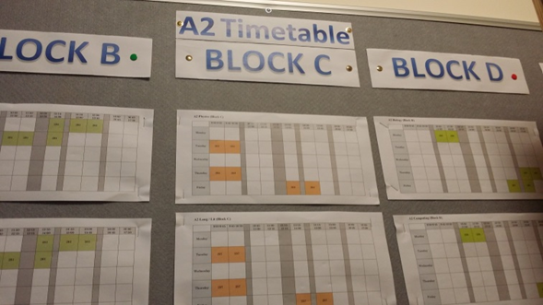

The Maths lesson timetable in Block B:

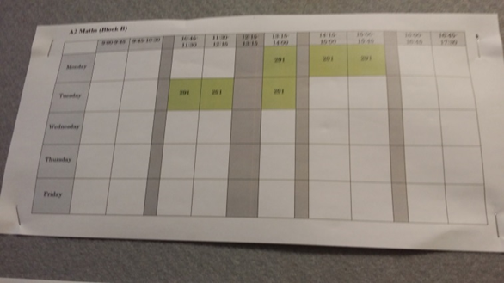

The Computing lesson timetable in Block D:

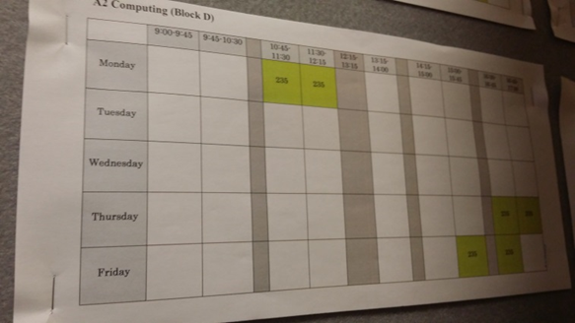

Update: as of January 2015, this board has been removed. Now, the only way for students to find out their timetable is to ask their teachers or classmates individually.

Prosolution  
This is how the timetable UI looks like for a single subject:

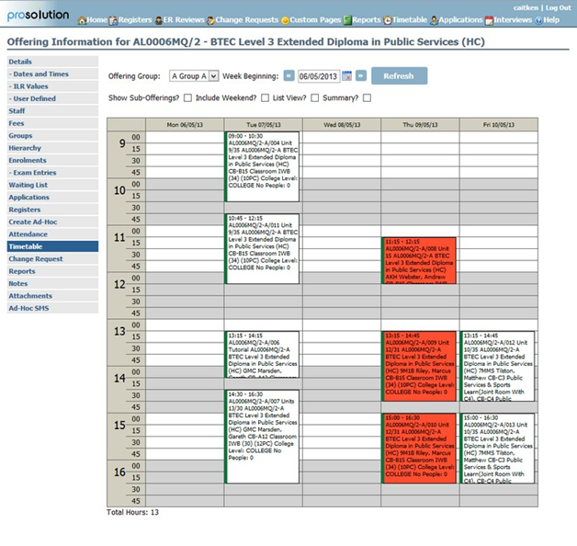

Teachers can take the register, update student progress and look at their timetable all through one website.

Teacher absences are notified by the PDC through text, or by the Head of year in an email form.  
Room changes are notified by the teacher themselves in a previous lesson of the same subject, or a notice is put on the door of the usual classroom.  
These changes, and also any other change or notice, is usually spread through word of mouth.

#### Summary of existing business limitations

Timetable board:

* There is only one board and it is on the second floor, therefore the system is geographically centric. This means the users spend extra time walking to this board and looking up their lesson’s timetable, which can delay learning.
* This board is not updated frequently; it does not have short term changes shown.

Prosolution:

* Displays too much unnecessary information on the timetable. This makes the UI look crowded and unpleasant to look at.
* Teachers cannot communicate with students on this service.

Word-of-mouth:

* Errors could accumulate in the retellings of the information.
* If this information is a lesson change, it might not reach every student of the class.

Putting notices on the door of the classroom:

* Students might not know where the new classroom is located.
* It could be seen as a waste of paper.

### *Functional Requirements*

The system should be able to:

* Successfully connect to the database.
* Log the correct people onto the website.
* Show the daily schedule specific to the user.
* Display the location of a classroom on a floor map as an image file.
* Allow teachers to add/modify/delete notices to different lessons.
* These notices should then be shown for those specific lessons until further modification.

### *Performance Requirements*

#### Speed

I will perform an HCI Analysis once the wireframes are designed, and the general numbers I will be using for different actions will be:

* Mouse Click: 0.1 seconds
* Mouse Select: 2.0 seconds
* Key Press: 0.1 seconds

The user interface should on average take less than a minute to navigate thoroughly, and less than 15 seconds to perform actions on each page. This is because the user interface should be to the point, therefore have a low number of actions for the user to perform.

#### Capacity

The prototype I will create will have a limited amount of data, however, at full commercial use for the whole of A2, the database should hold information on:

* Number of Courses: 17
* Number of Teachers: 21
* Average Number of Students per class: 10
* Estimate Number of Enrolments: 170
* Number of Lessons: 102
* Estimate Number of Rooms A2s use: 25

Therefore, for a single academic year, the system should be able to hold and process 1,547,595,000 unique pieces of data in total. This number is the product of all the input information.

#### Reliability

The system should have minimal or 0% downtime.  
In terms of maintenance, only the staff who is responsible for the maintenance should be the one who can access and modify the database from phpMyAdmin.  
The database should be backed-up by exporting both when the phpMyAdmin application is first opened and when it’s going to be closed.  
If problems arise, the latest backup should be available to import back into phpMyAdmin. This process should take no longer than a minute.  
PhpMyAdmin also has a tracking feature in which it tracks every change that has been done to the database. If problems occur, it should be easy to track down the cause of it.

#### Usability

Users:

* The staff that will be responsible for the maintenance of the database should have training in using phpMyAdmin.
* Teachers and students who will be using the system need to know how to navigate through a website. For the locations of classrooms they also need to know how to find their way via a floor map.

The system should work on standard keyboards.  
The system should have a cross-platform capability, so it can be used with different operating systems.  
The website should be easy to view on PCs, laptops, tablets and smart phones. This is so that the website is easily accessible on the go.

### *Design Constraints*

Hardware and software: I have to code the website in such way that it will be easy to view on mobile and tablet browsers.   
My skills and knowledge: The website nor the database can be too complex for me to build. I will be using phpMyAdmin for the database, and PHP, HTML and CSS to create the system.  
Legal: To avoid the risk of violating the Data Protection and Child Protection acts, I will not use real data for the prototype of the system.  
Time: The project needs to be completed by a given deadline.

### *Commercial Constraints*

Since this will be a bespoke system for Tresham College, it is ideal to work in the college’s colour scheme. The website should also have the Tresham logo, visible both on the webpage and as a favicon.

# System Analysis & Design

## Preliminary Design Stages

This system is going to be generating a timetable system, therefore information for it would have to come from the MIS department of the college. The type of information would include enrolments, class lists, timetables, staffing lists, student lists and room lists.

The system will be running off a web server because it is intended to be run by the college, and to be used for multiple systems running simultaneously. While the web server will be running on a raid hard disk it will be doing a continuous real time backup.

### *Textual Analysis*

I analysed my project objectives and requirements, identified the different nouns and actions, which then gave me a list of potential classes and routines that will equate to tables and queries.

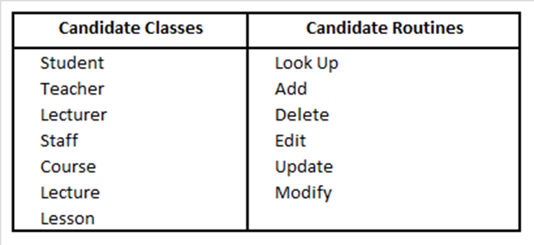

### *Significant Event Analysis*

From my functional requirements and the candidate routines from the textual analysis, these are the different events that must be performed by the system. This analysis also shows what tables and attributes will be needed for the queries of these events.  
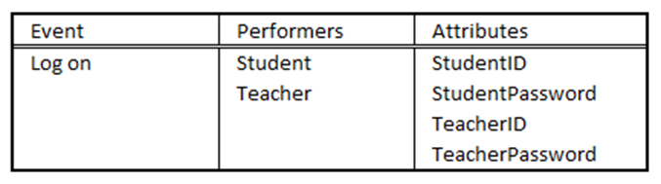

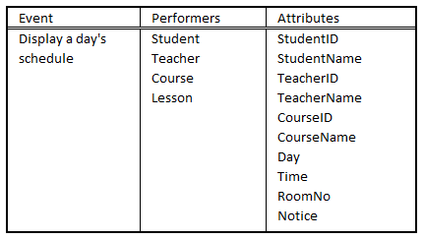

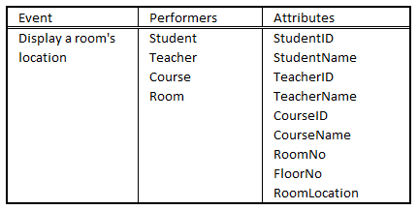

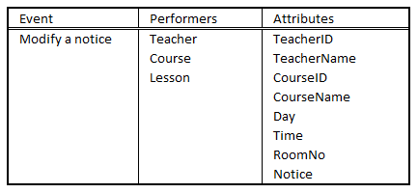

### *Commands and Queries*

These are the commands for the events that have to take place, and the queries that will be used for different functions to work successfully.

Commands:

* Log in students and the teachers that are on the database.
* Show the schedule of the student or teacher depending on the day they select.
* Show the room location of a room a student or teacher selects.
* Enable teachers to modify the “Notice” field through the UI.

Queries:

* Searches for a match for the user logged in, in the student table.
* Searches for a match for the user logged in, in the teacher table.
* Searches for a match for the StudentID and StudentPassword from the data entered and submitted by the user.
* Searches for a match for the TeacherID and TeacherPassword from the data entered and submitted by the user.
* Searches for a match for the user logged in the StudentID column and grabs their name.
* Searches for a match for the user logged in the TeacherID column and grabs their name.
* Lists the student's schedule depending on the day selected and submitted.
* Lists the teacher's schedule depending on the day selected and submitted.
* Lists all the room numbers.
* Searches for a match for the RoomLocation and FloorNo from the room number selected and submitted.
* Lists everything on the lesson table that the teacher teaches.
* Updates Notice from the data entered and submitted by the user.

## Detailed Static System Designs

### *First Draft BON System Architecture Diagram*

These BON diagrams show the data fields of every table, the client/supplier link between tables, and the foreign keys.  
  
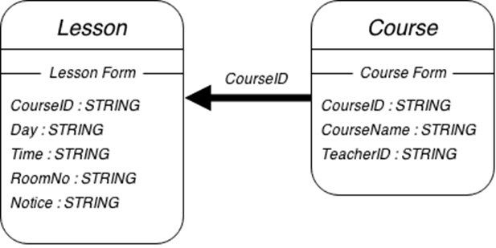

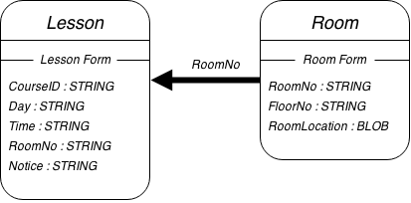

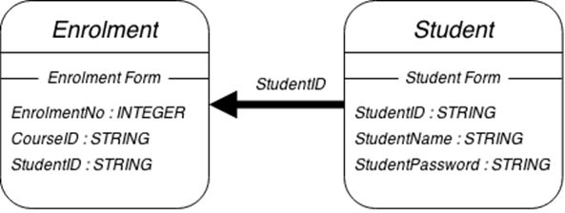

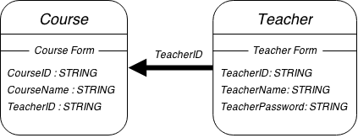

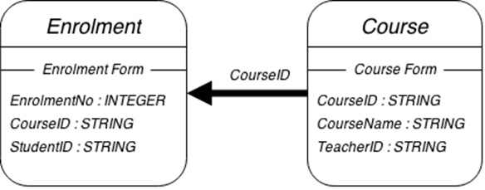

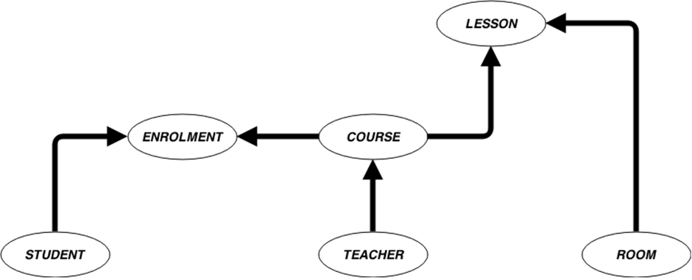

### *BON Class Charts*

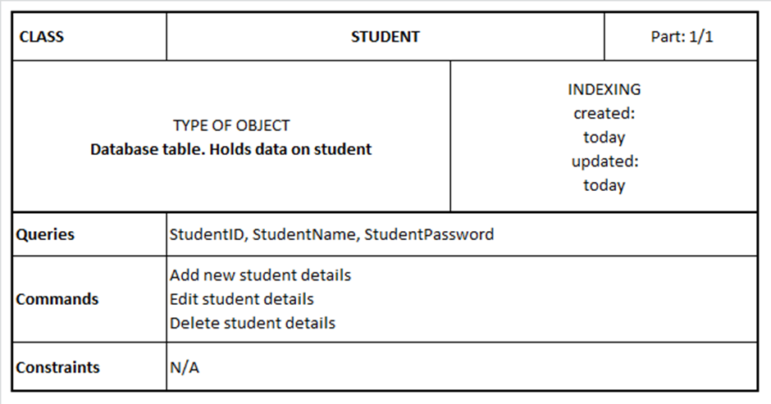

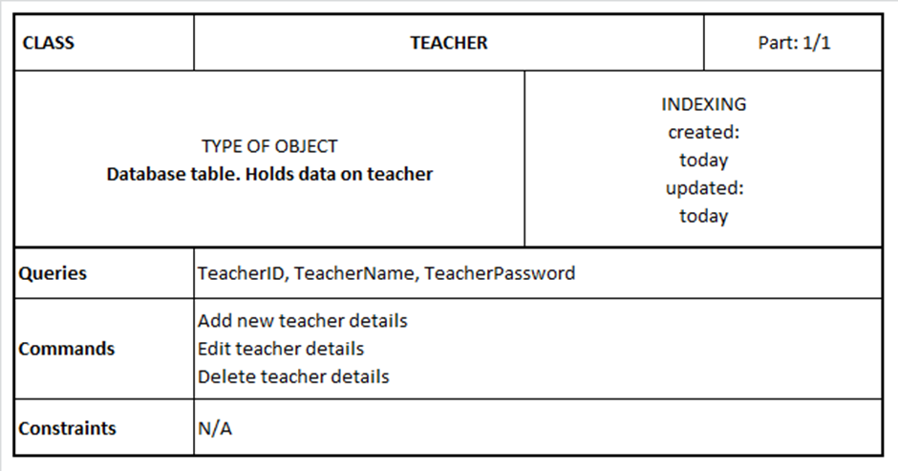

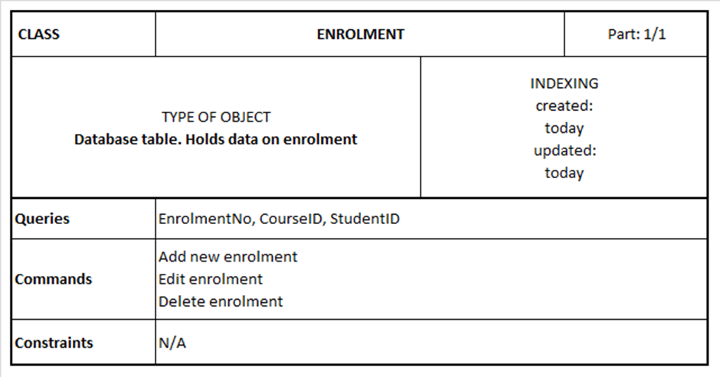

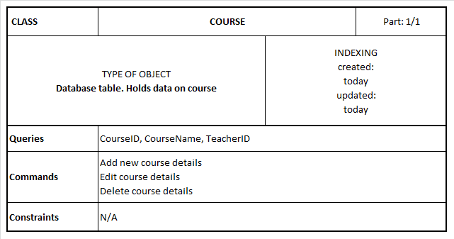

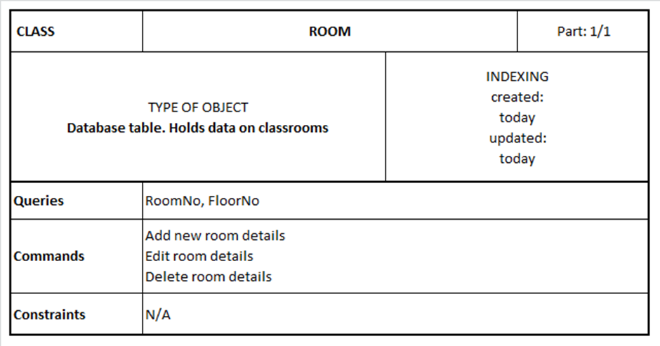

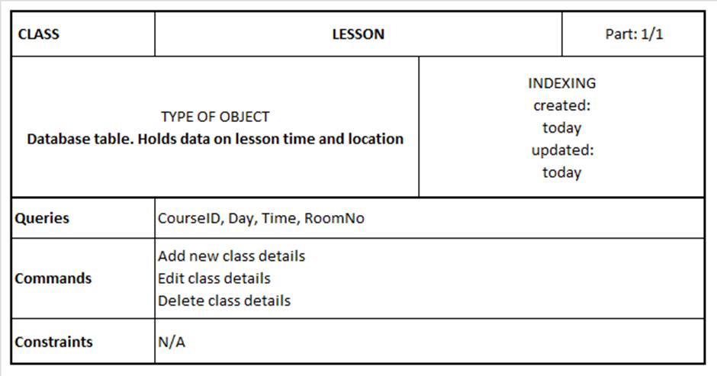

# System Interface Designs

## Draft Interface Designs

### *Wireframes*

The main frame will always be proportionate to the size of the user’s screen. Therefore, to centralise, it will be 50% from top and 50% from left, with no specific dimensions set. It will have 25px padding and a 3px solid white border.

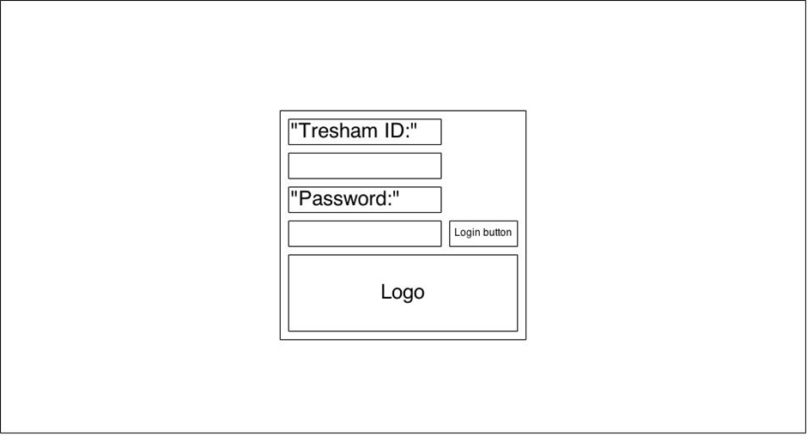

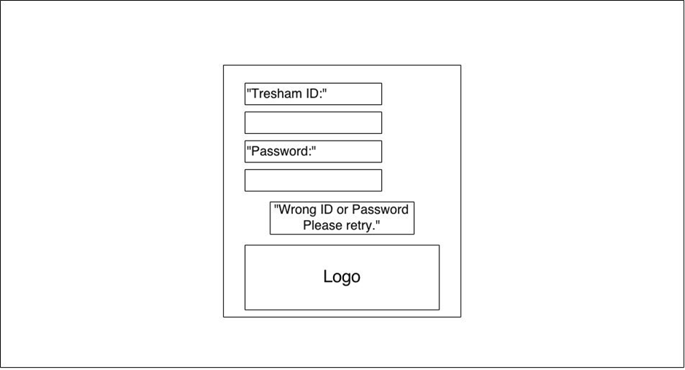

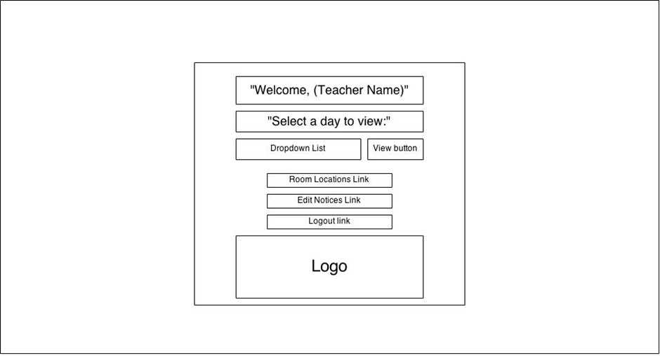

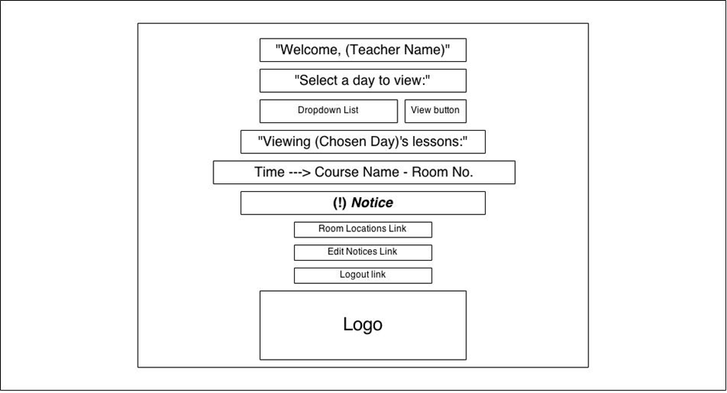

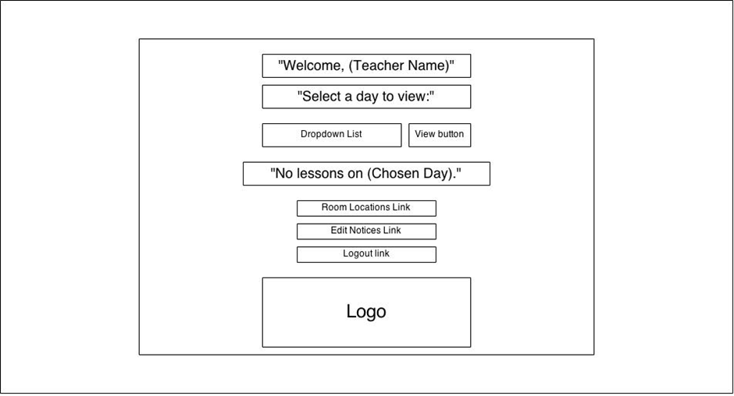

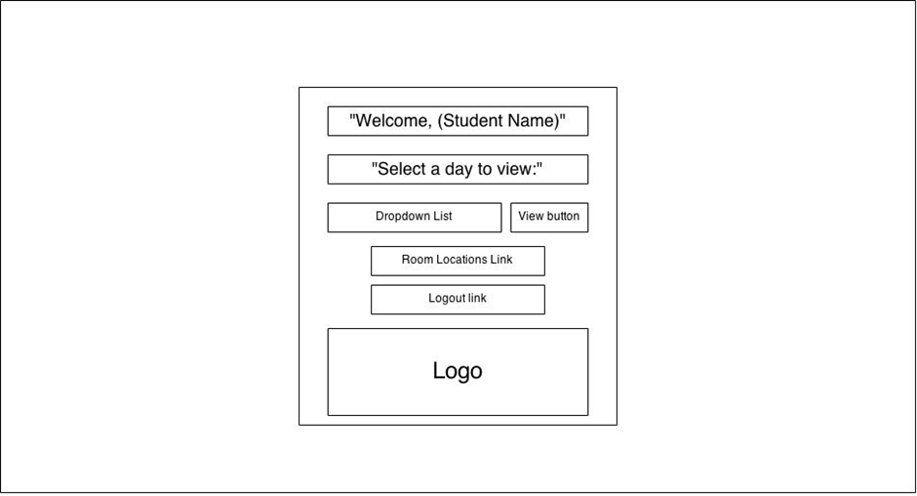

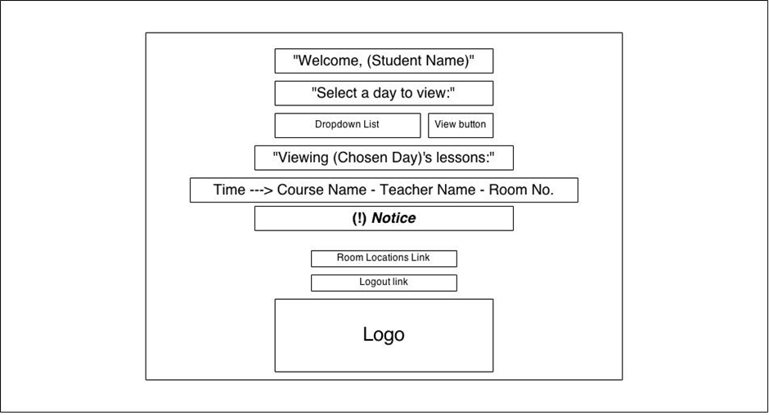

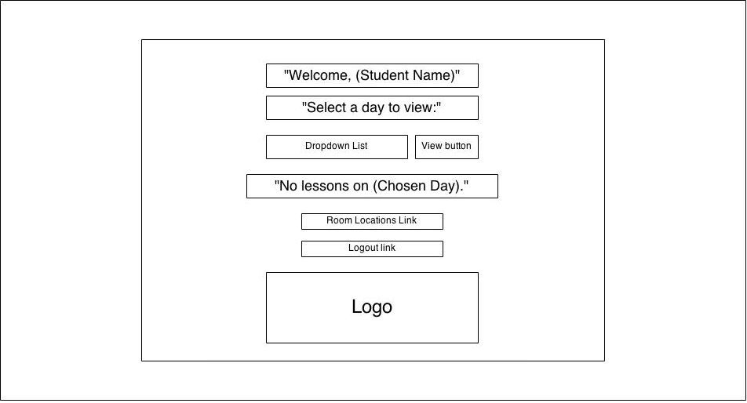

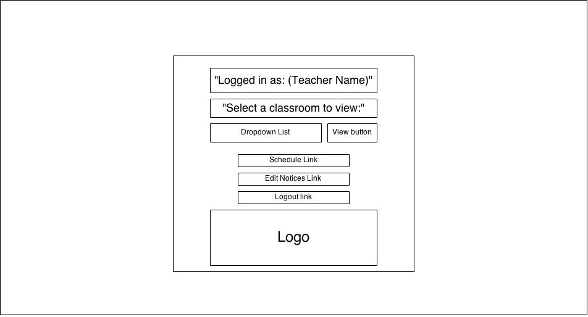

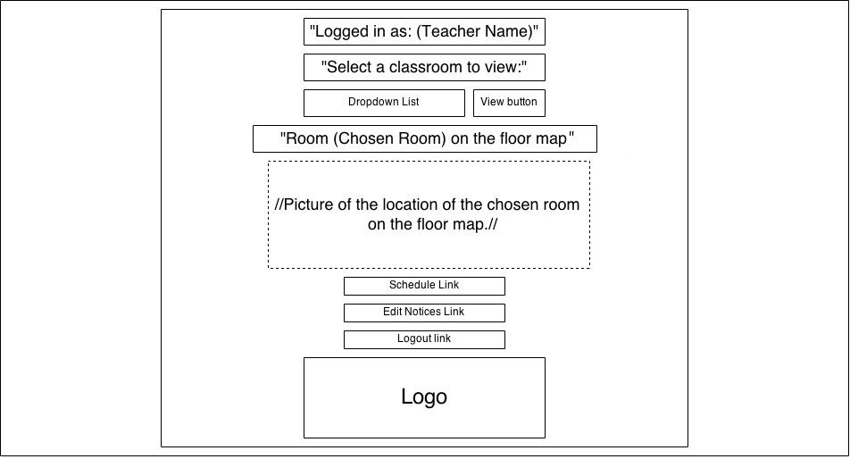

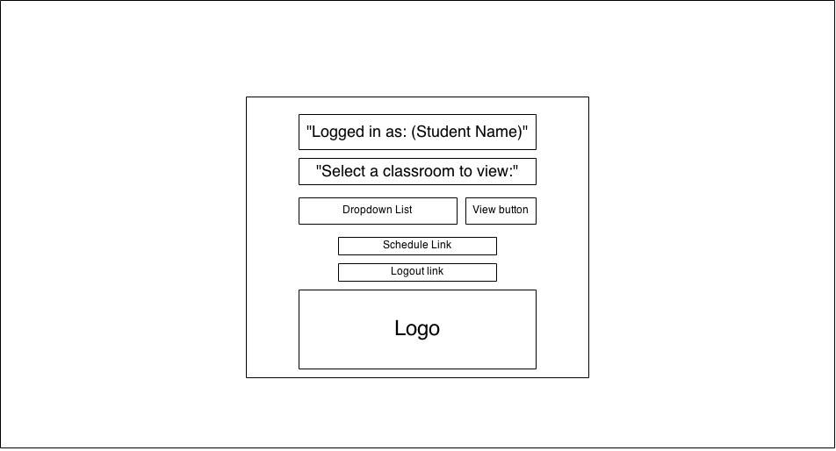

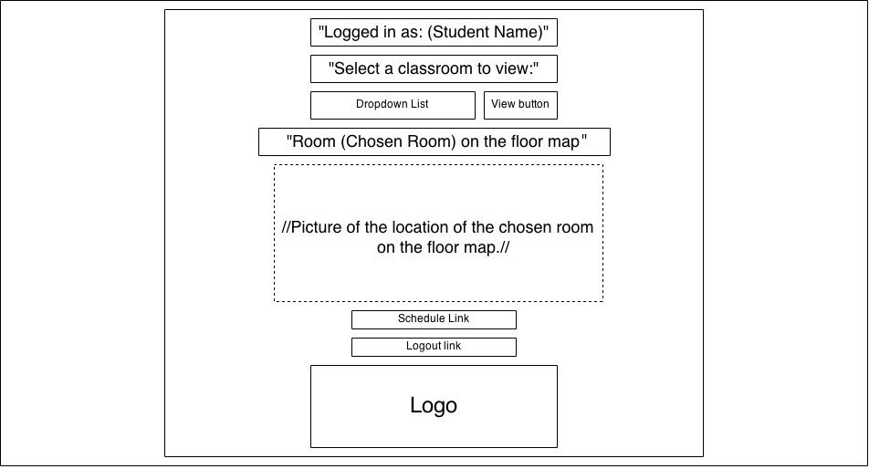

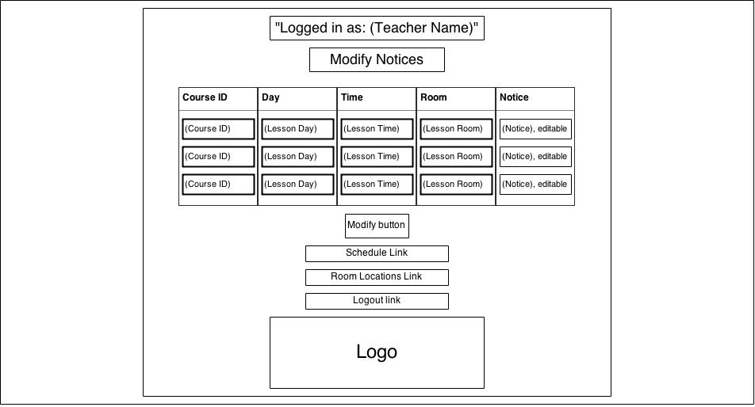

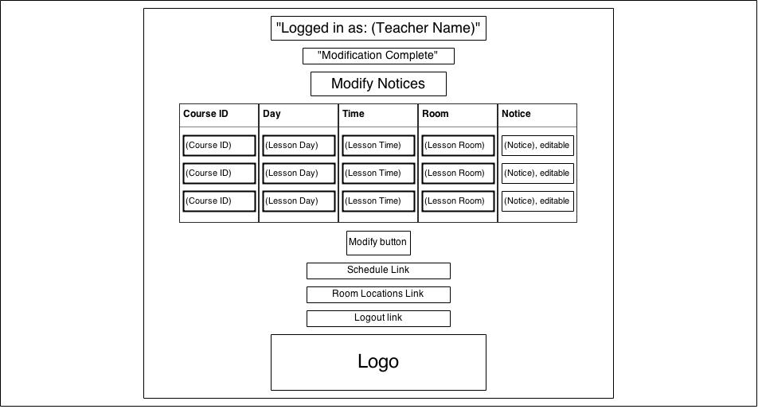

#### HCI Analysis

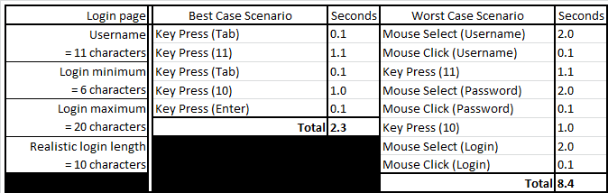

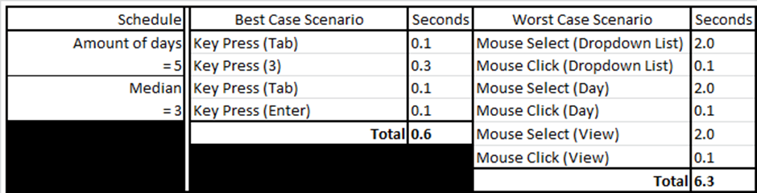

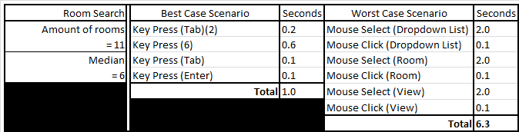

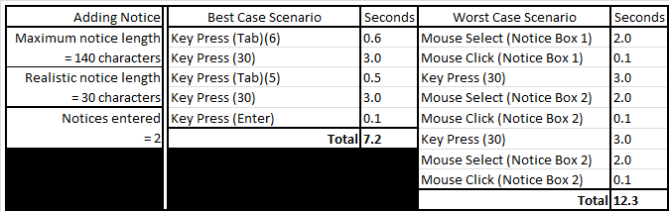

### *System Navigation Diagram*

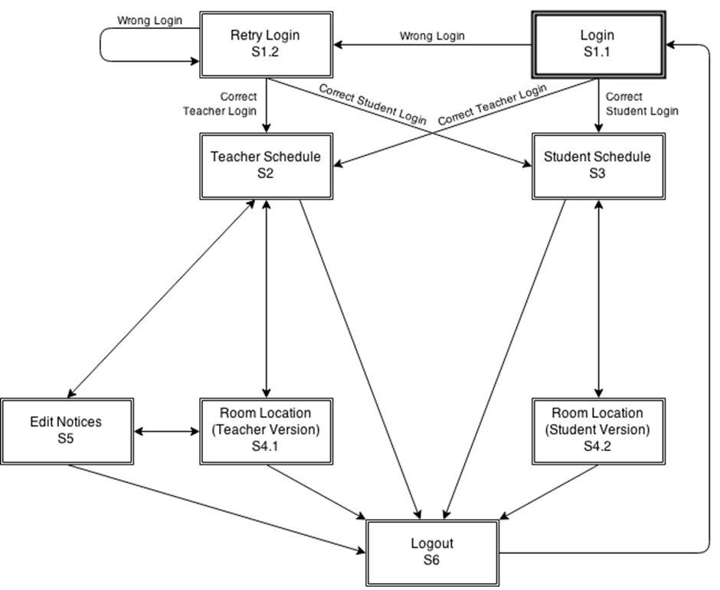

### *System Screen mock-ups*

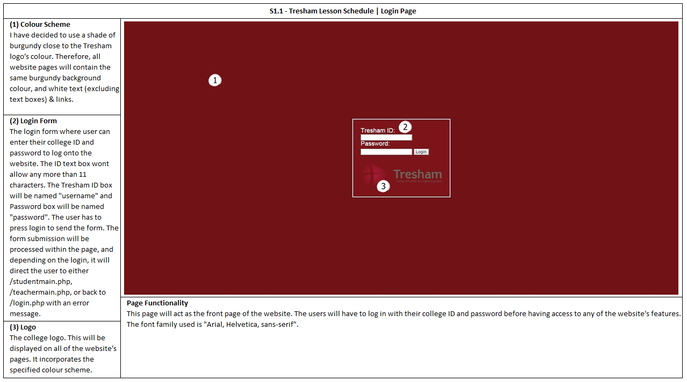

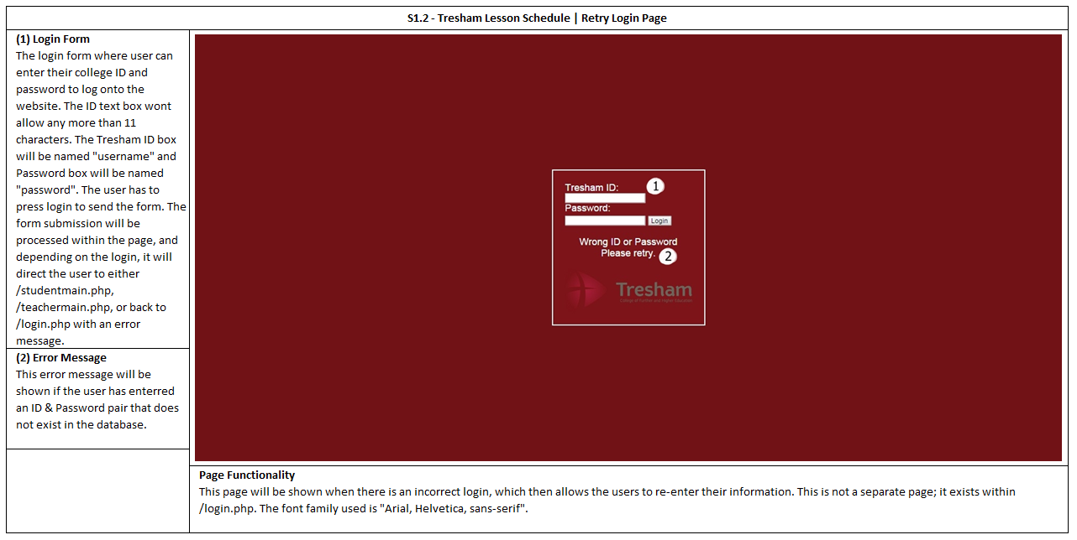

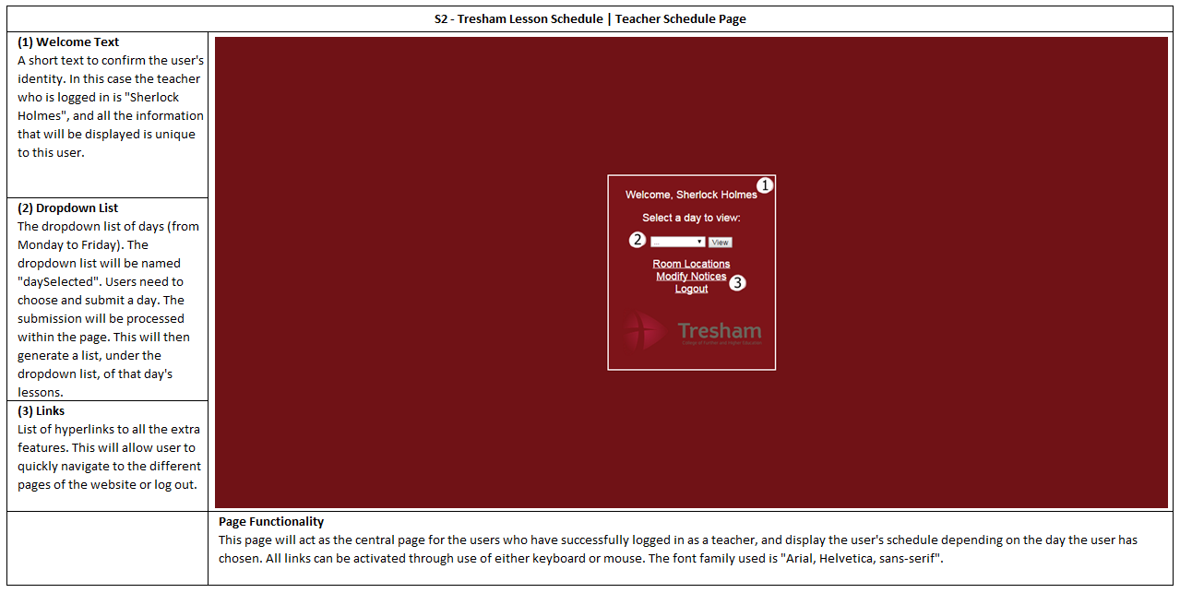

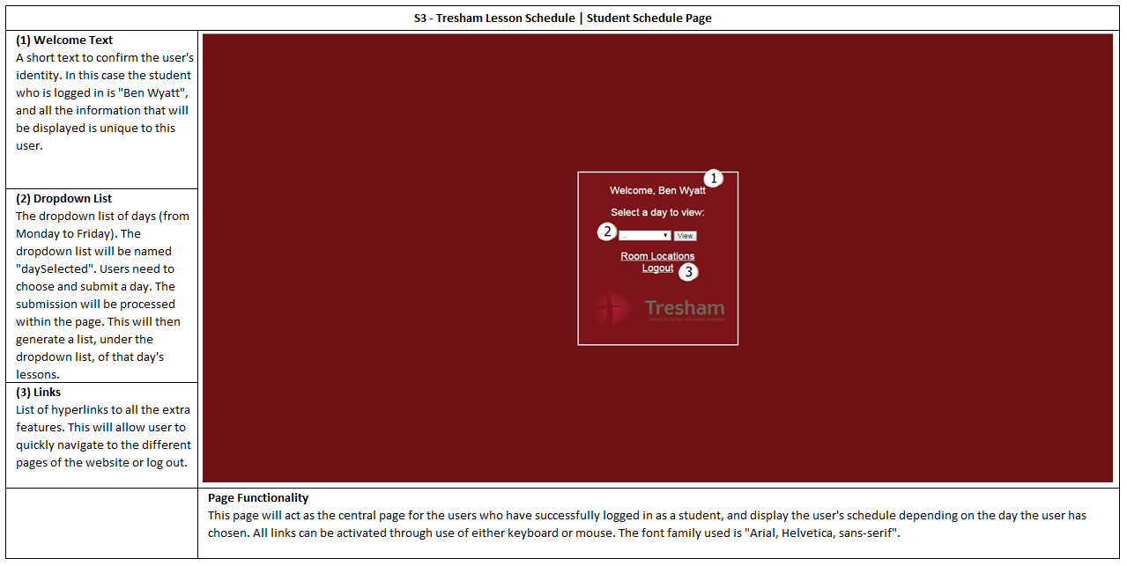

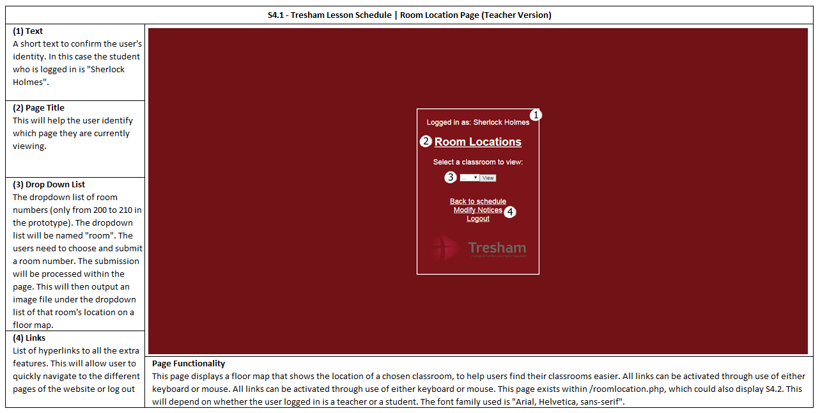

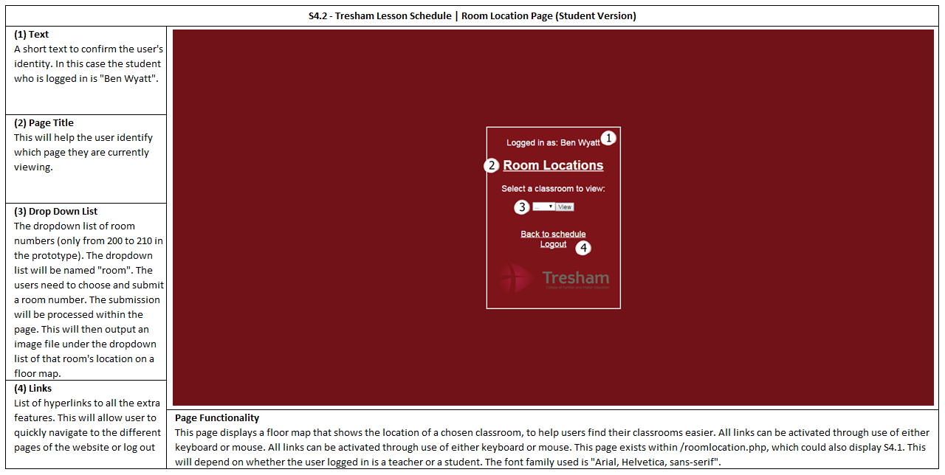

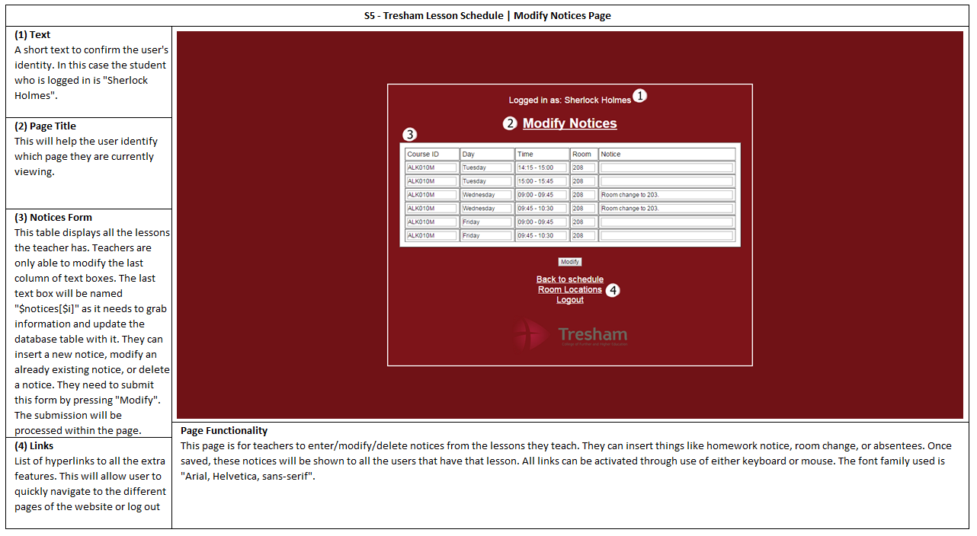

### *System Activity Event Diagrams*

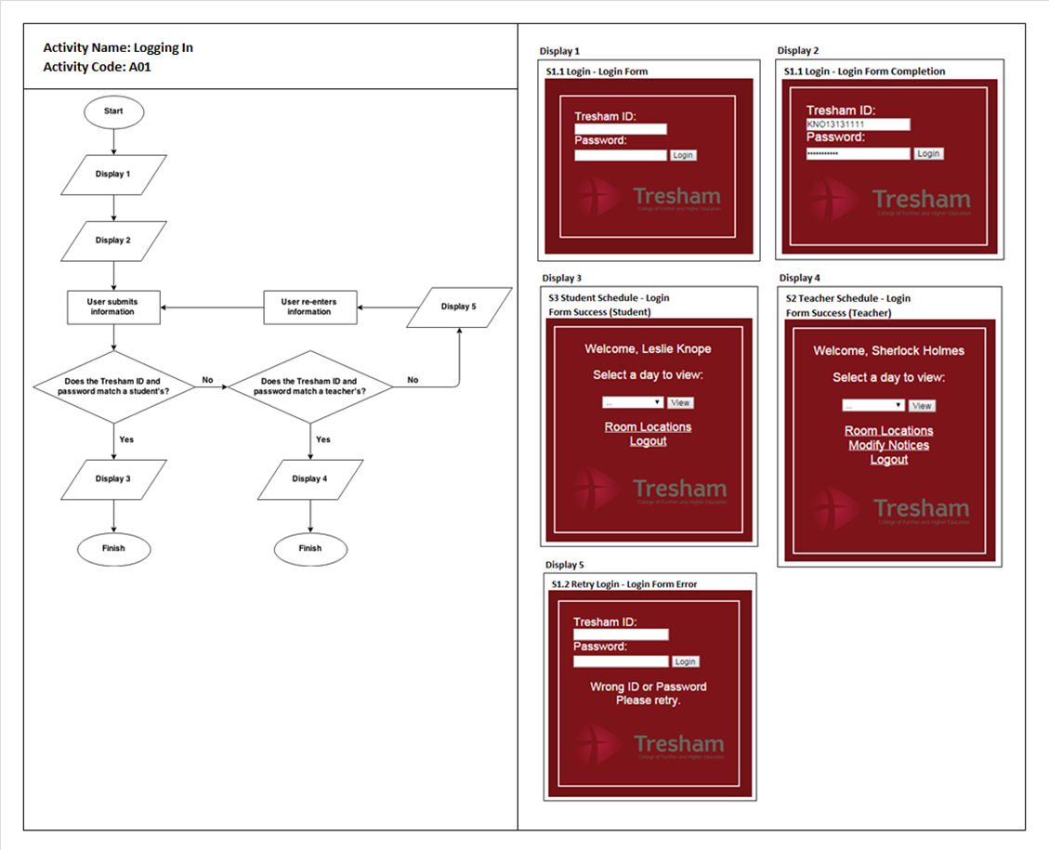

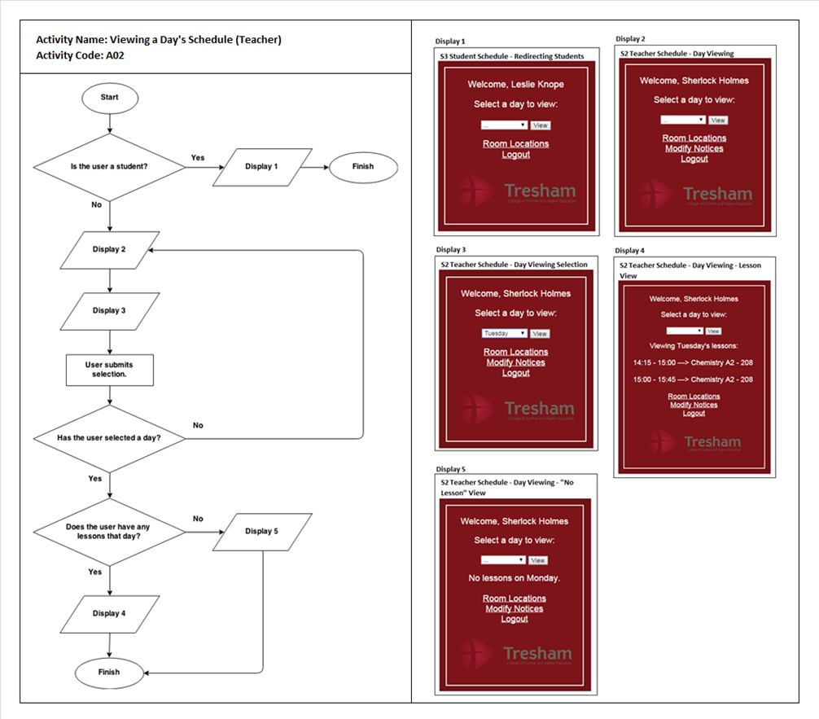

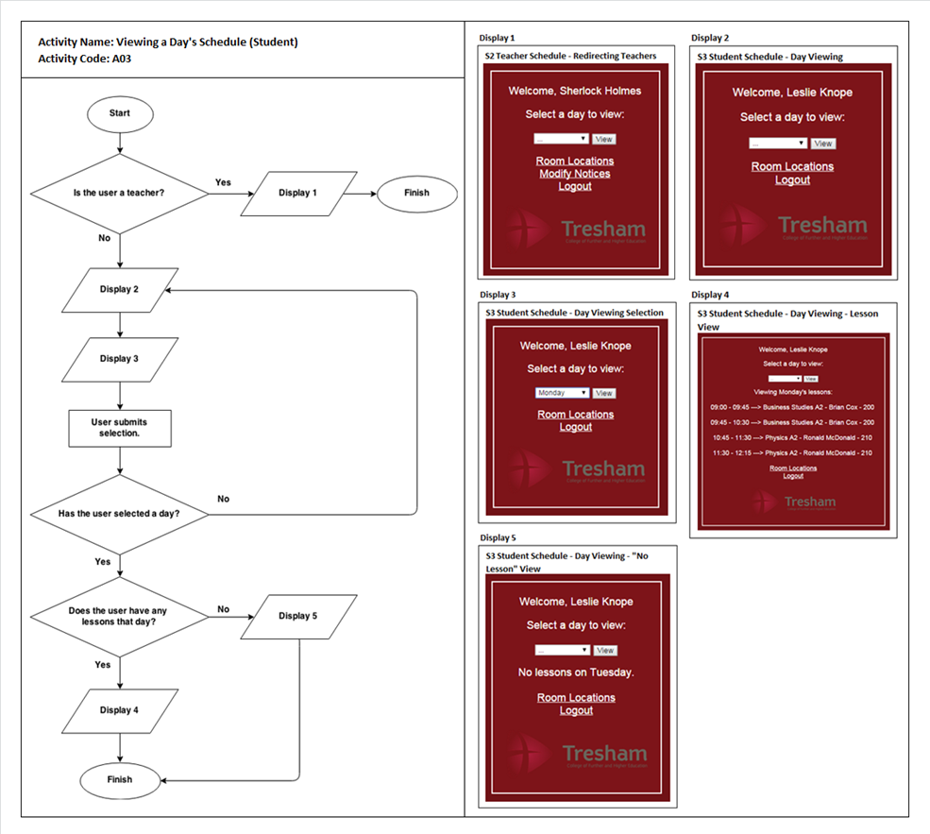

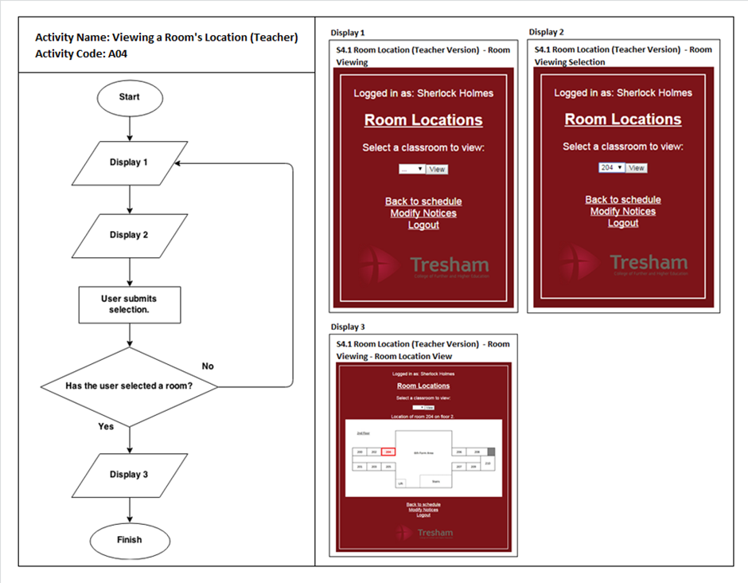

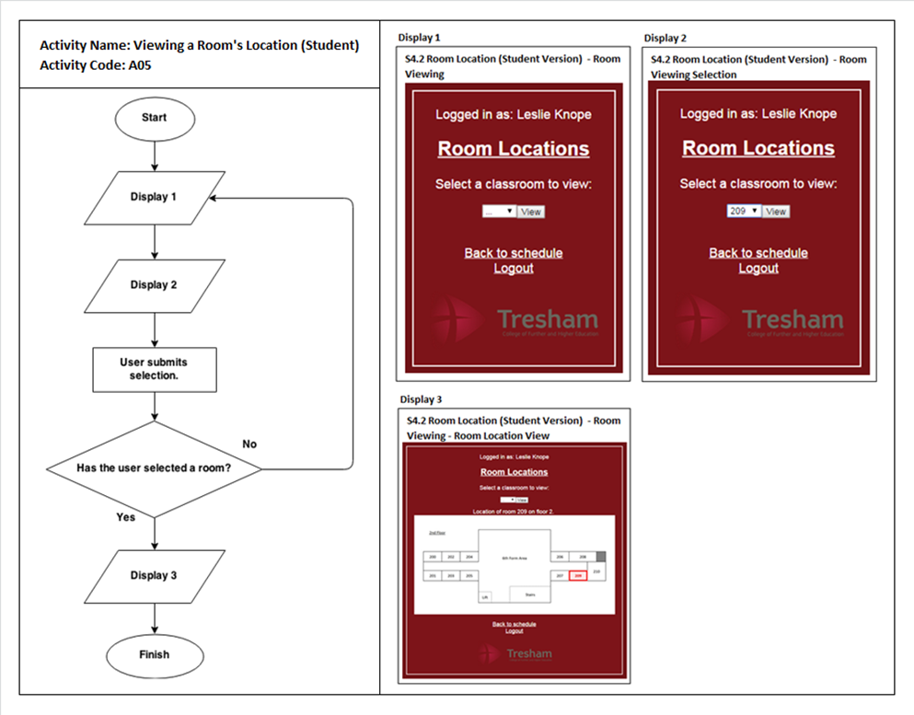

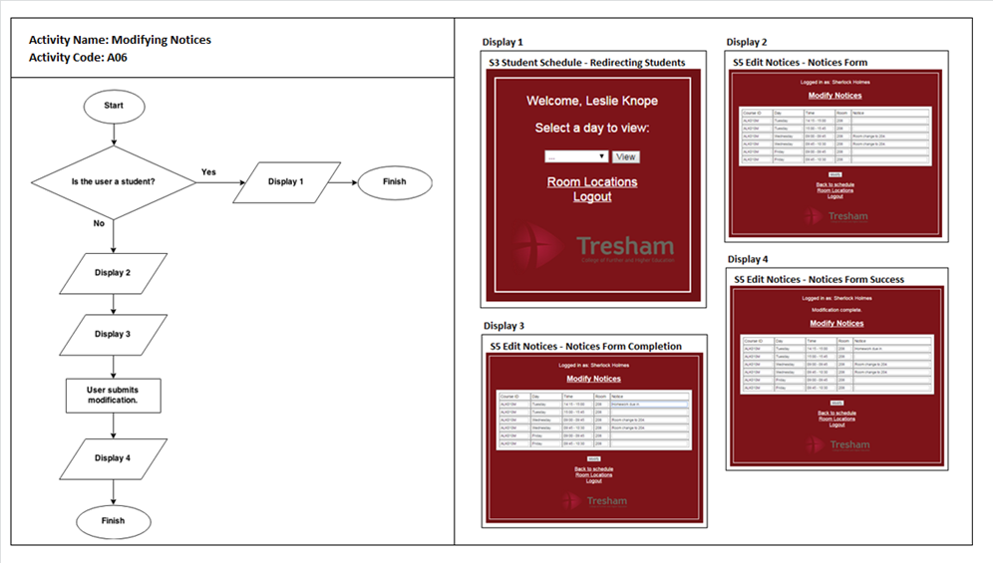

## Database Design

### *ERD*

Key:

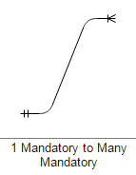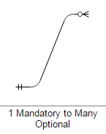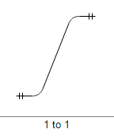

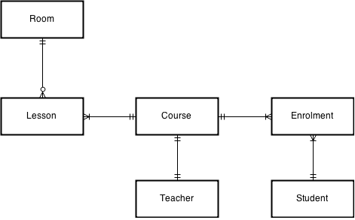

### *Data Dictionary*

The data dictionary tables below do not include foreign keys.

#### Student table

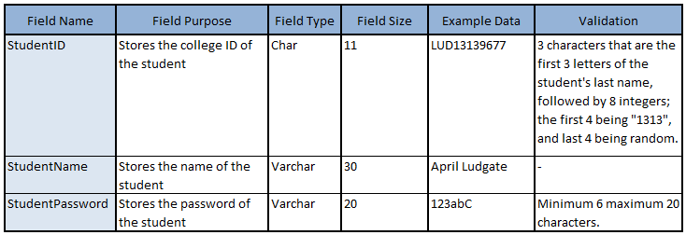

#### Teacher table

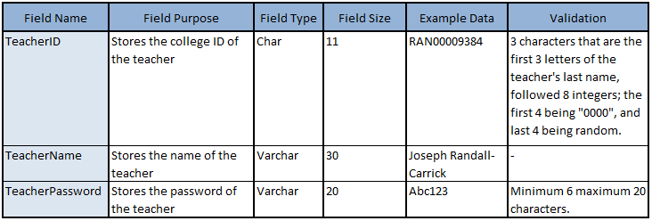

#### Course table

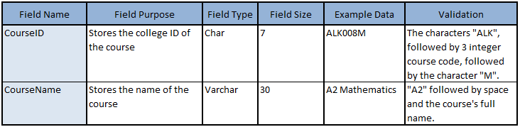

#### Enrolment table

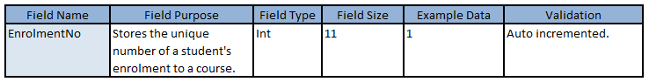

#### Lesson table

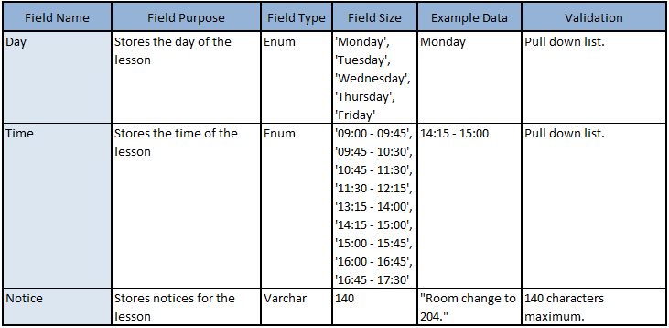

#### Room table

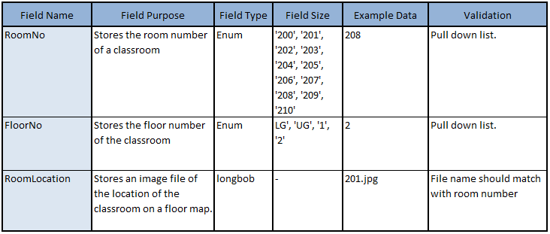

### *Queries*

### *Reliability*

To meet the user requirements of reliability, the database and the UI will be separate. Regular maintenance of the database will be to back up tables daily. There is no downtime required. If the database crashes, the most recent backup can be imported to phpmyadmin.

Incase the user inputs an invalid type of data during logging in, login.php will have a data validation function. This code will:

- Strip unnecessary characters such as extra space, tab, and new line.   
- Remove backslashes.  
- Convert special characters to HTML entities.

In order to protect the html and php code from breaking.

# Build report

To build my project I have downloaded and am using WampServer. It allows me to create a web application with Apache2, PHP and a MySQL database. Its functionalities are very easy to use. For the database, I am using phpMyAdmin, which is automatically installed alongside WampServer. This program allows me to easily create and manage databases.

The system I am building is not at commercial size; therefore it would need few tweaks before it can work on that scale. However, the prototype should run smoothly on all platforms that have WampServer or XAMPP and phpMyAdmin installed.

## Database

Creating the Database

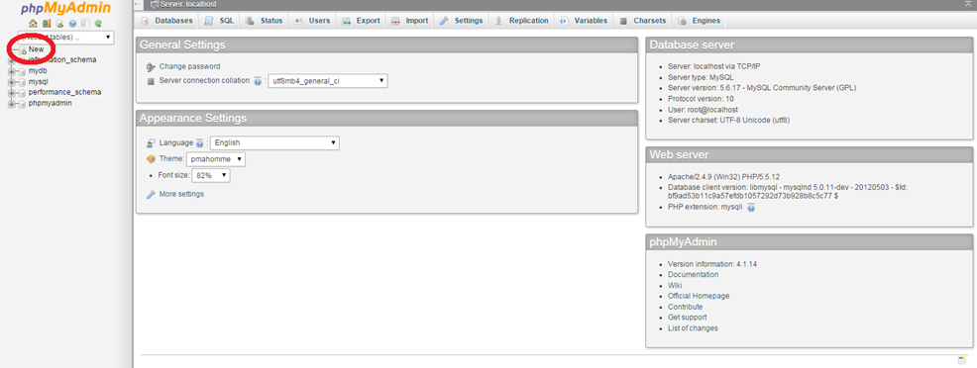

When I first logged onto phpMyAdmin, this was the screen I was welcomed to. To create my database, I have clicked the highlighted button, and was taken to the form below.

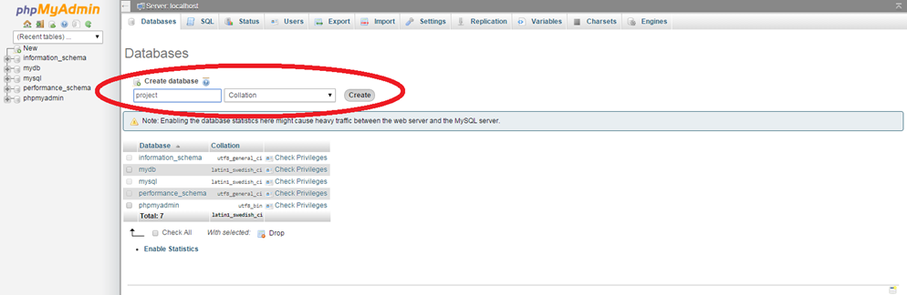

Here, I entered the name for my database, and clicked “Create” to create the database.

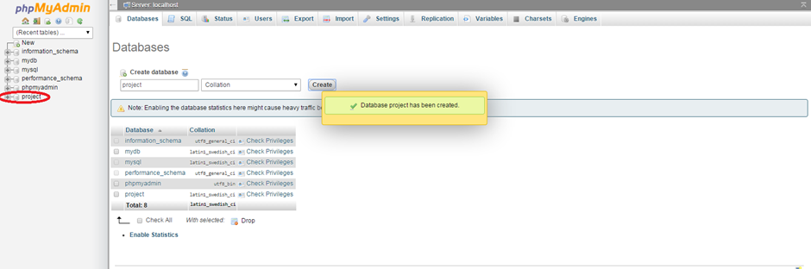

I then received this notification confirming the creation of the database. This was also confirmed by the ‘project’ database being listed on the left hand side.

Creating the first table

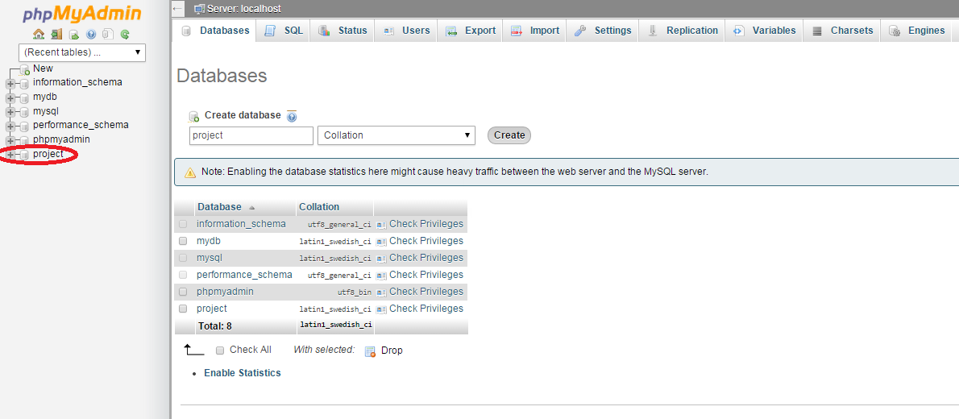

Once I created the database, I clicked the new ‘project’ database link, and was taken to the structure tab of the database.

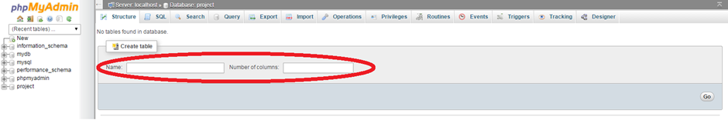

Because the database didn’t have any tables, the structure tab did not have anything to show, and therefore just displayed a form to create a new table.

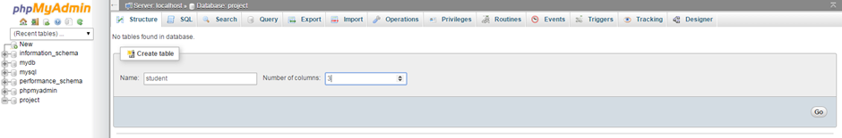

I decided to create the student table first, with 3 columns; StudentID, StudentName, StudentPassword. Once I entered name of the table as ‘student’ and number of columns as ‘3’, I clicked “Go” and was taken to the form below.

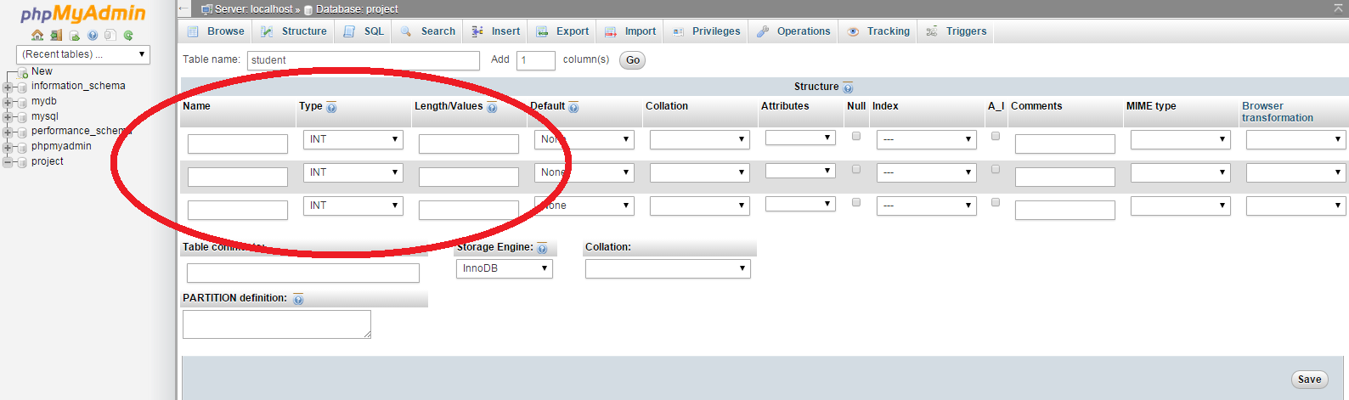

The form showed me three rows where I can enter information about the 3 fields. I only had to enter the first three columns because of the type of field.

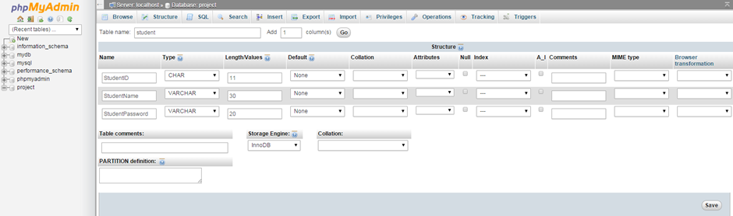

After entering the information above, I clicked “Save”.

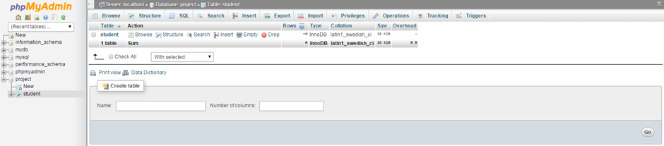

I was then taken to the screen above, now showing ‘student’ as one of the tables of the database, confirmed by the new ‘student’ link under the ‘project’ database link on the left hand side.

I have used this method to create all the other tables.

Populating a table

For the prototype of the system, I have created my own student/teacher data. I have decided to have 10 students and 7 courses (therefore 7 teachers), and matched students to courses in such way that it would portray real life situations such as two lessons happening at the same time (therefore the student has to pick one of the two). This allows me to put data into the database without worrying about legal constraints.

Once I created a table, I populated them before going onto creating the next table. I started with the table ‘student’ so this table was the first one I populated.

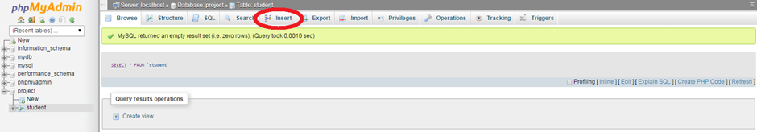

When I clicked the ‘student’ link under ‘project’ database, I was taken to the browse tab. The tab ran the “SELECT * FROM ‘student’” query but showed no results as the table was empty. To input values into the database, I clicked on the insert tab. The form below was displayed.

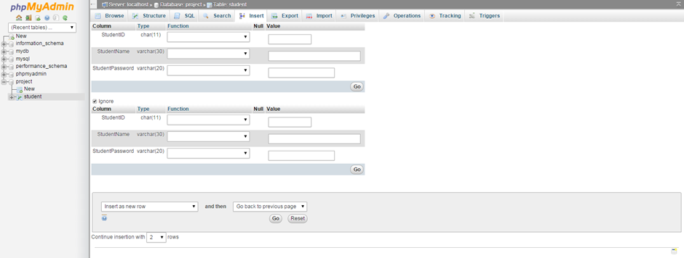

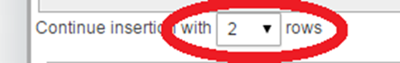Because I had 10 different student’s information to enter, I changed “insertion with 2 rows” to 10 rows.

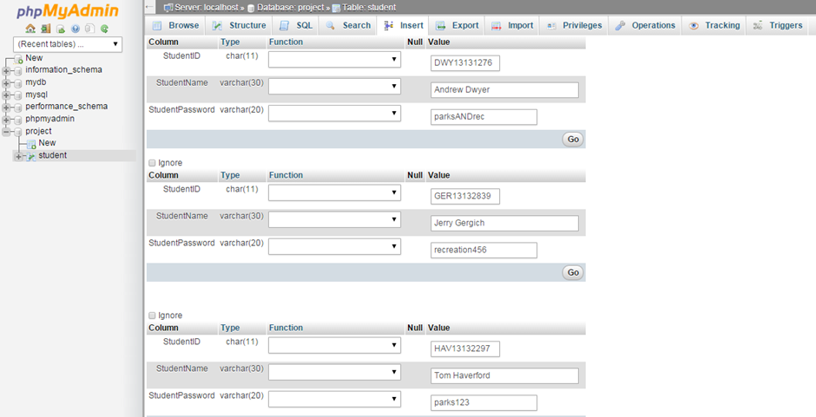

I then started entering the students’ information.

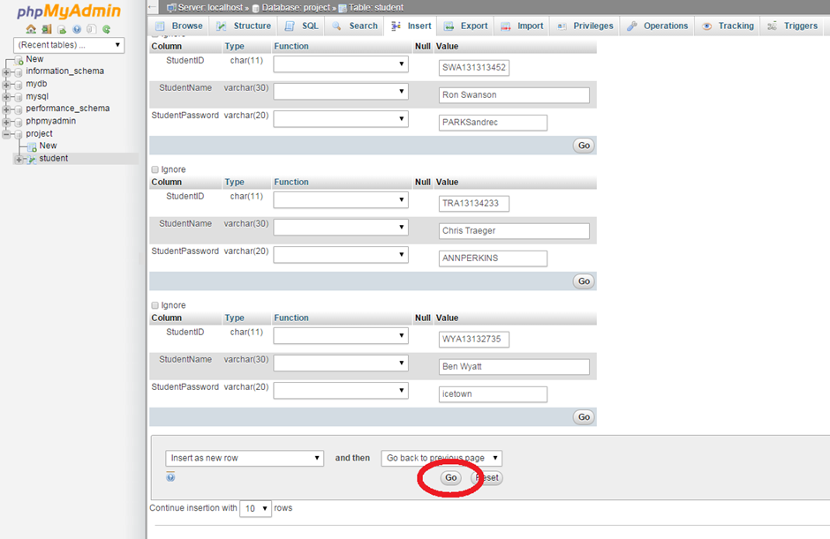

Once I finished entering all 10 rows, I clicked “Go”.

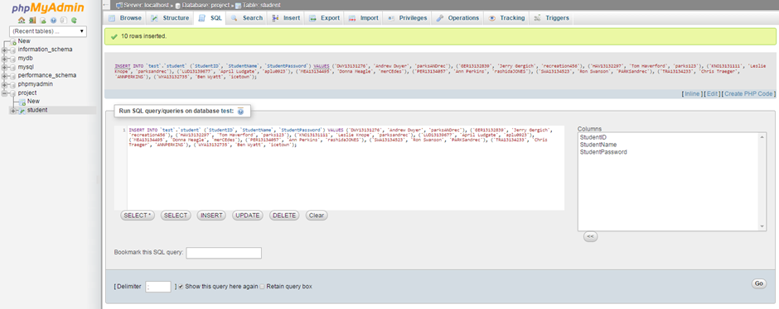

phpMyAdmin then ran a query, inserting all the information I entered into the table.

I have used the same method on all tables to populate them.

Creating primary keys

I had to set StudentID as the primary key of the table ‘student’, therefore from the last screen I clicked on the structure tab.

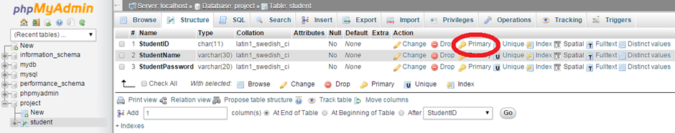

This was now how the structure tab looked like, and it allowed me to set StudentID as the primary key simply by clicking the highlighted “Primary” option.

I have used this method to set the primary keys of all the other tables.

Creating relations and foreign keys

Once I created and populated ‘teacher’ table, and created the ‘course’ table, I have decided to link these tables together by setting the “TeacherID” field in ‘course’ as a foreign key.

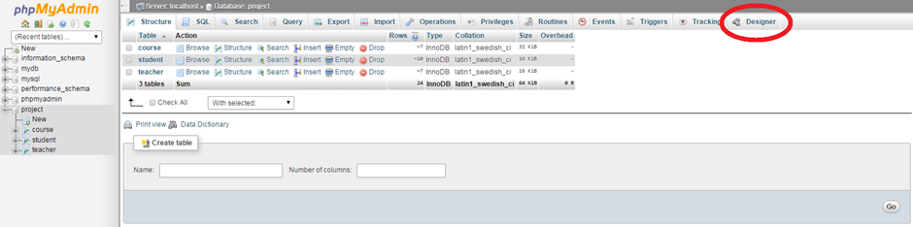

I clicked the ‘project’ database link on the left to see overall look of the database (it automatically took me to the structure tab). From here, I clicked on the highlighted designer tab.

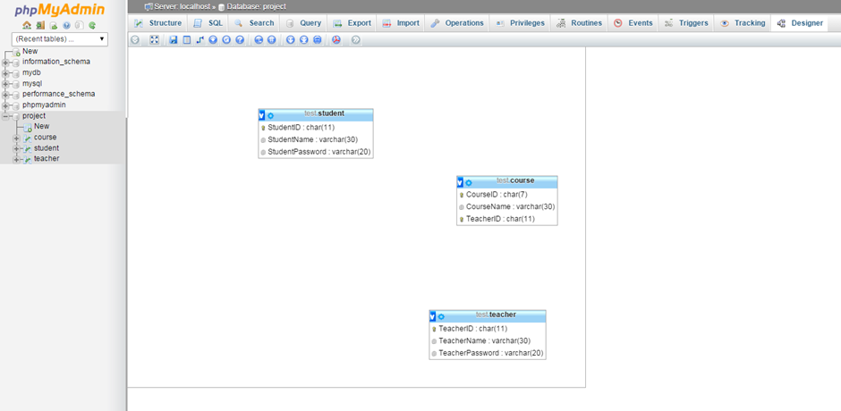

I was shown this screen of an incomplete ERD.

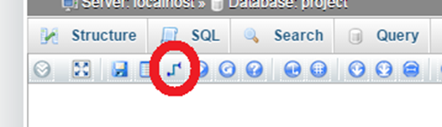

I clicked this option, which is used to create relations between two tables.

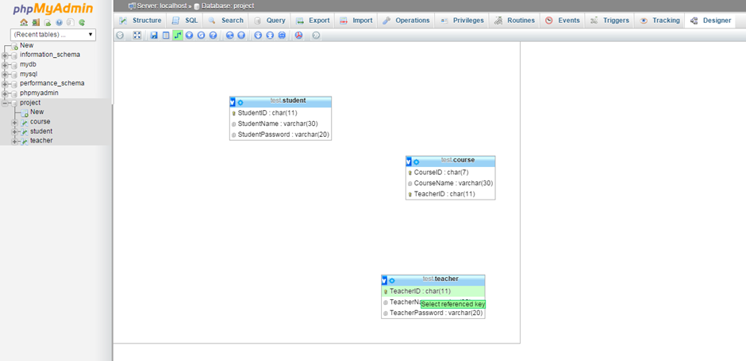

Once I clicked the option, phpMyAdmin first asked me to pick the referenced key.

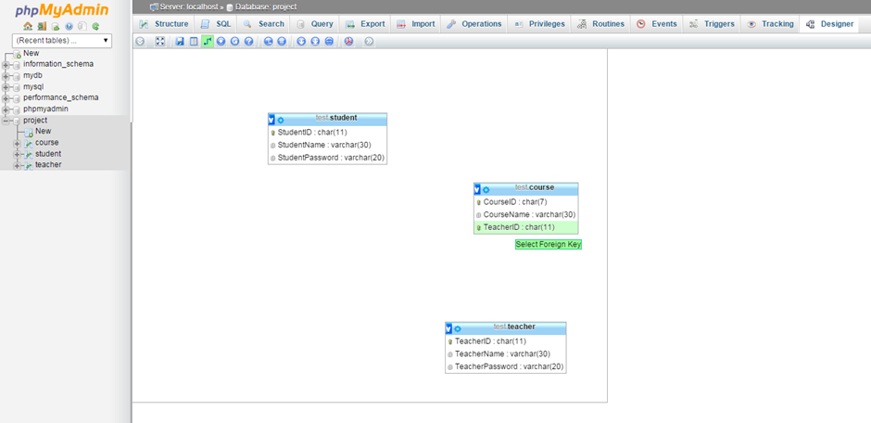

Then the foreign key.

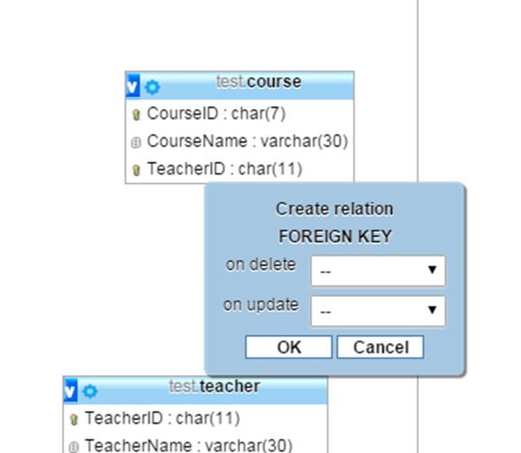

Selecting both the referenced and foreign key correctly generated this box.

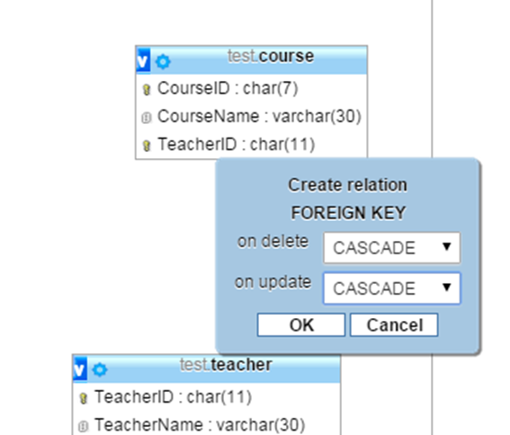

I selected both to cascade, as I wanted the information changed in “TeacherID” under ‘teacher’ table to be applied to “TeacherID” under ‘course’ if the information was to be altered.

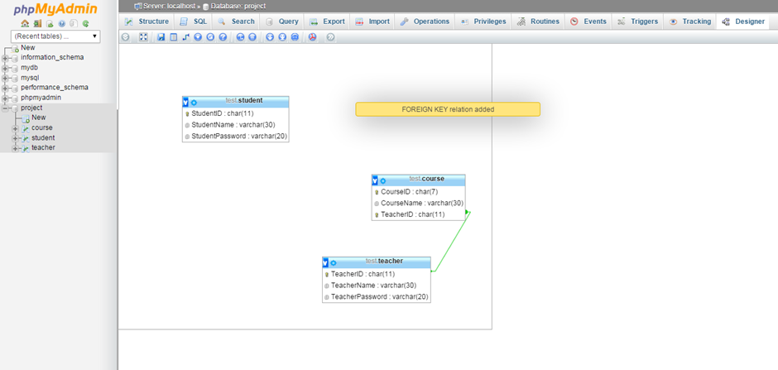

Once I pressed “OK”, this notification was displayed, with now “TeacherID” under ‘teacher’ table having a visible link with “TeacherID” under ‘course’.

I have used this method to create relations between all the other tables I have created.

This is the final look of the database and relations between tables from the designer tab:

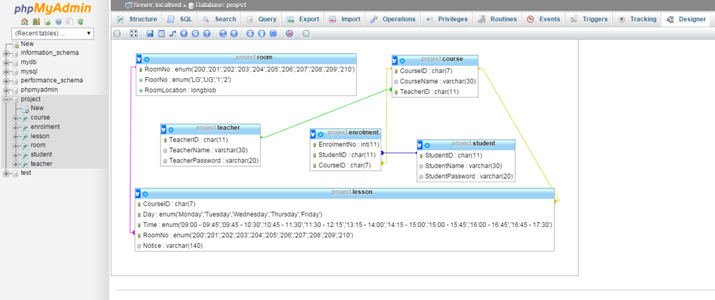

## Website

Login.php

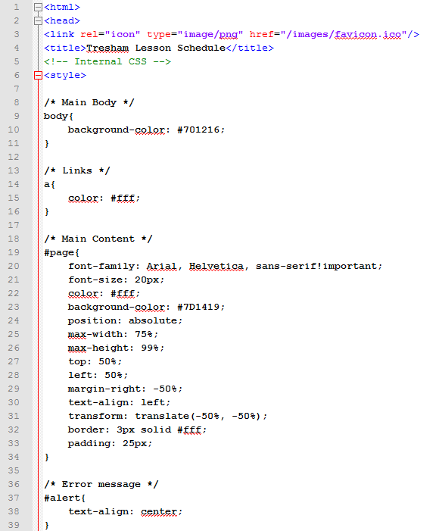

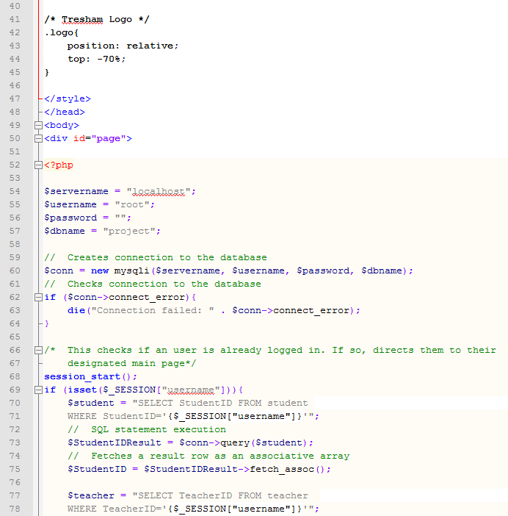

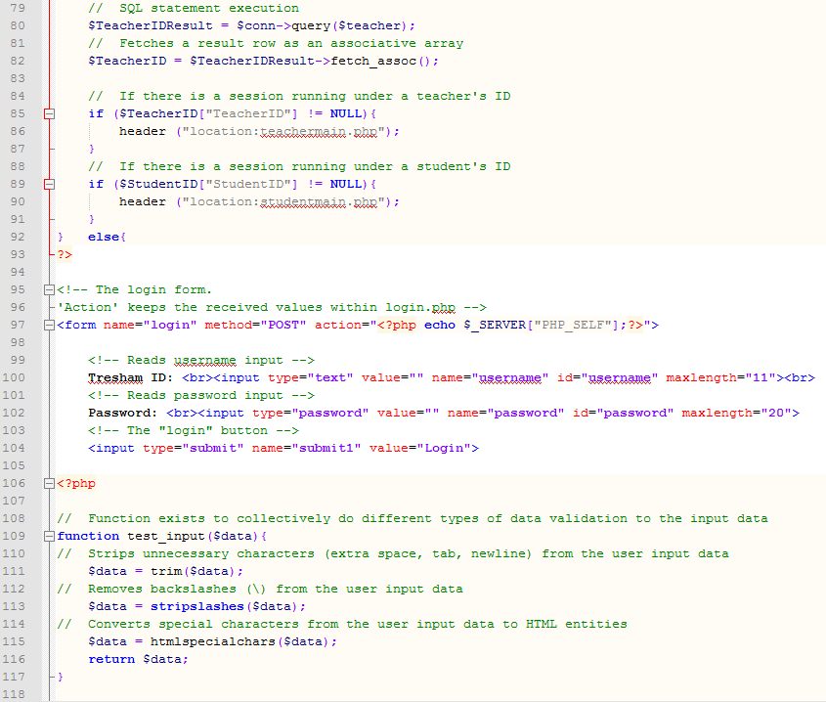

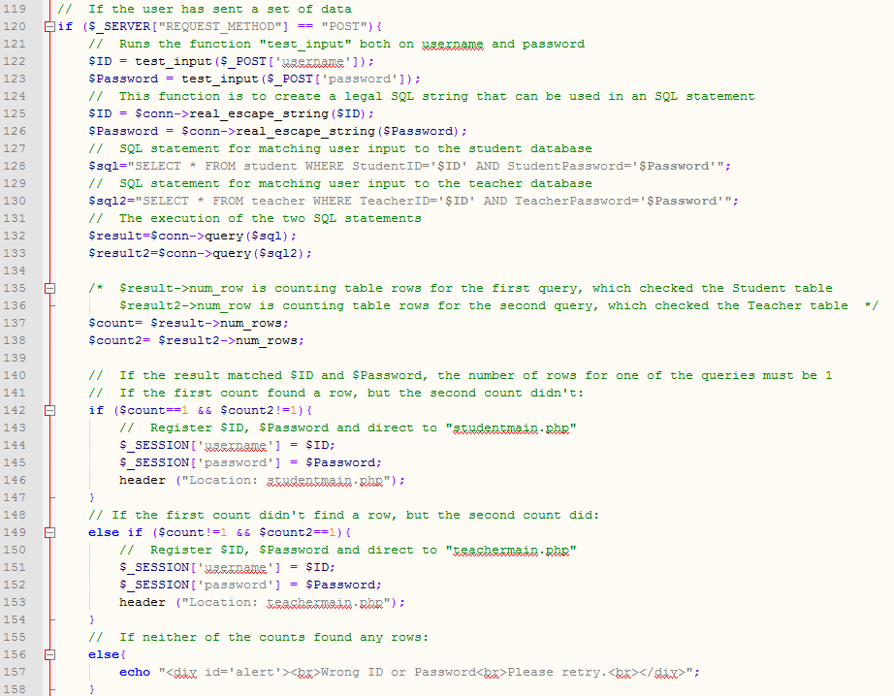

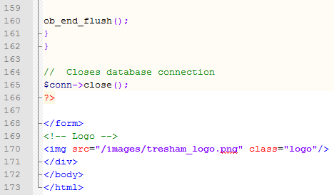

Teachermain.php

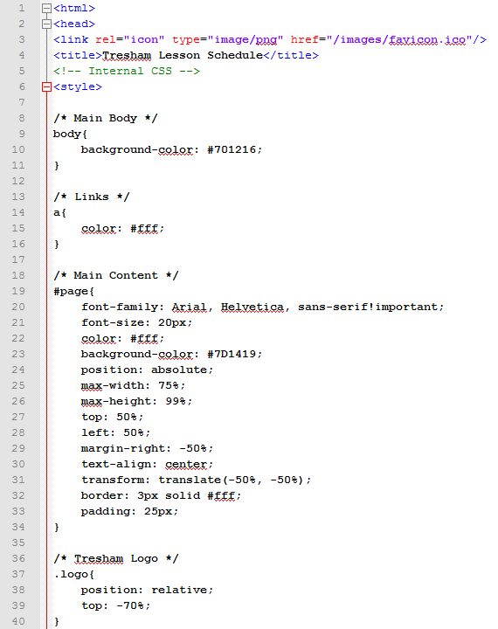

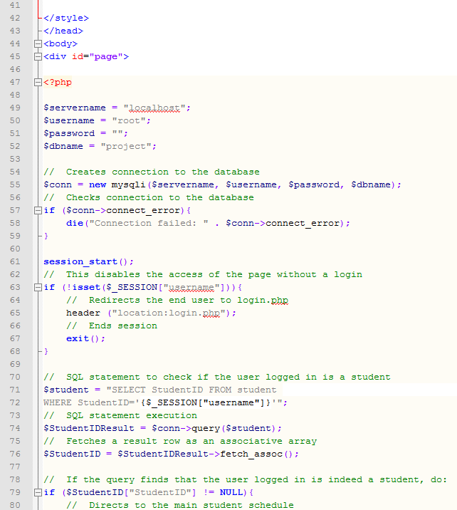

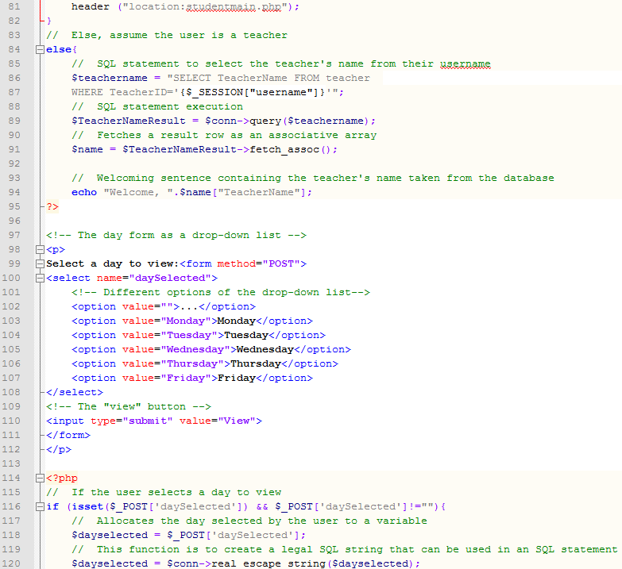

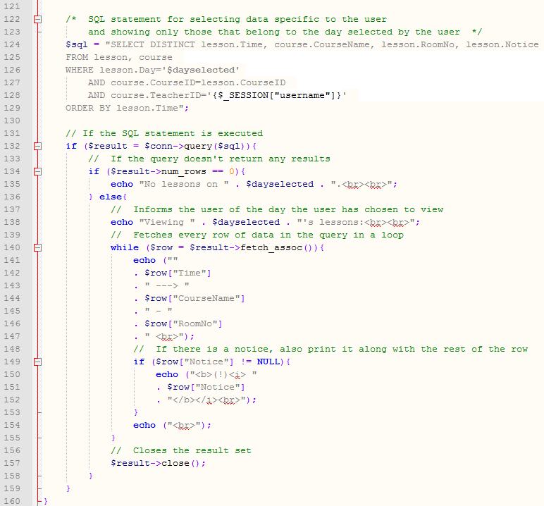

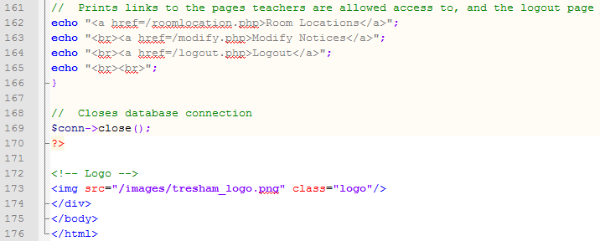

Studentmain.php

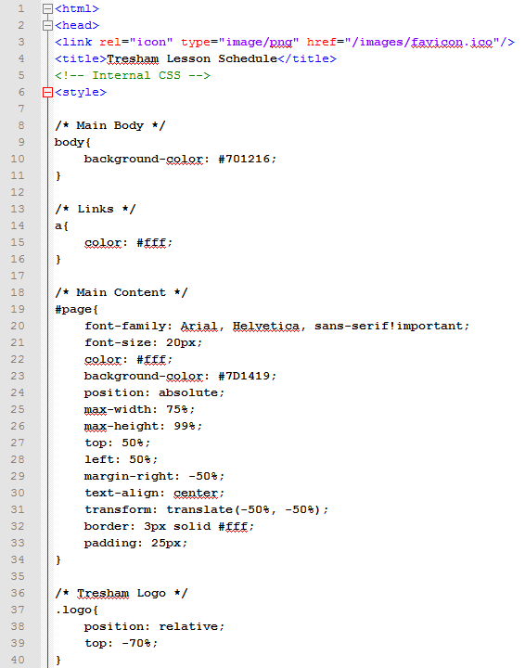

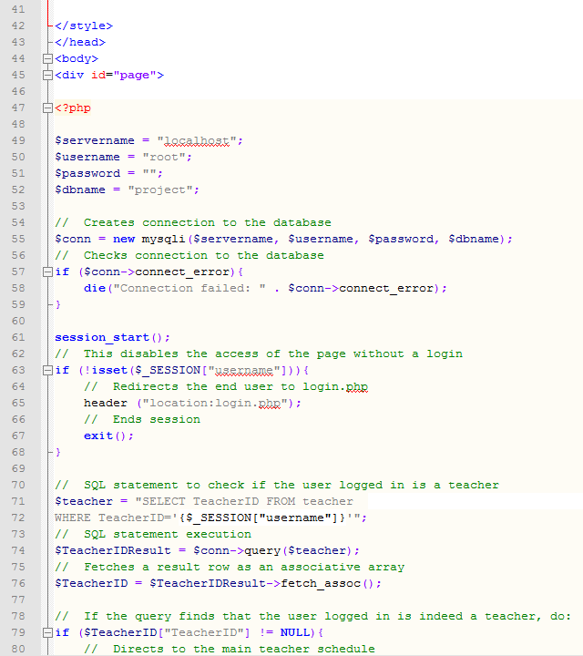

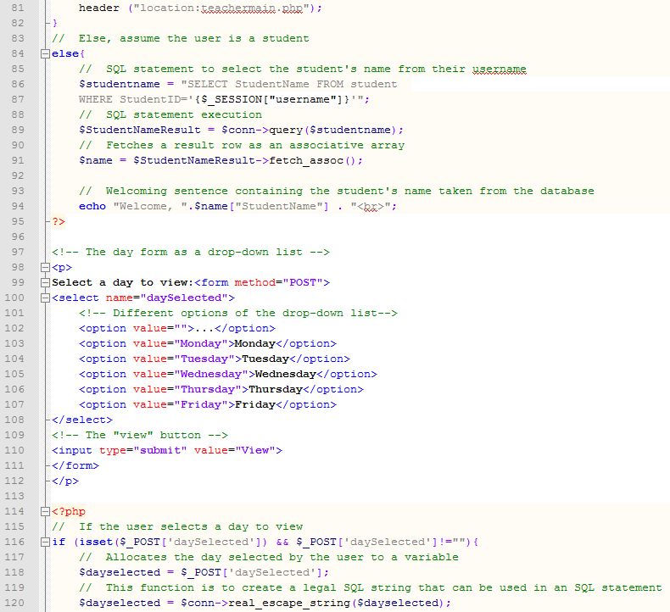

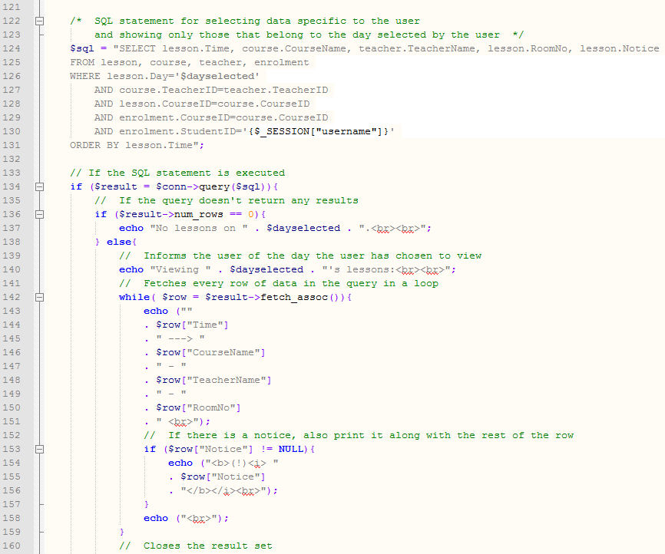

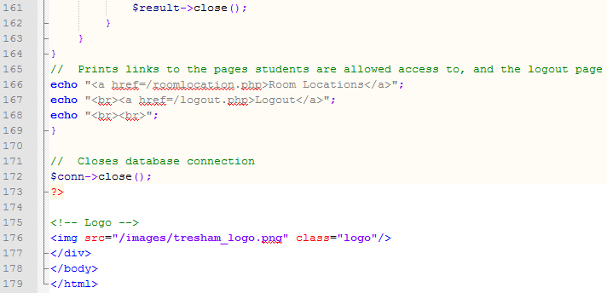

Roomlocation.php

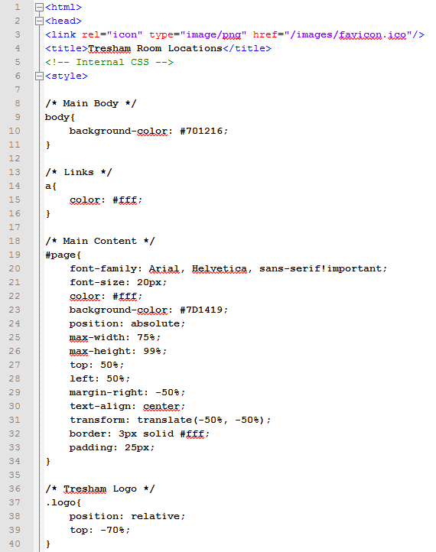

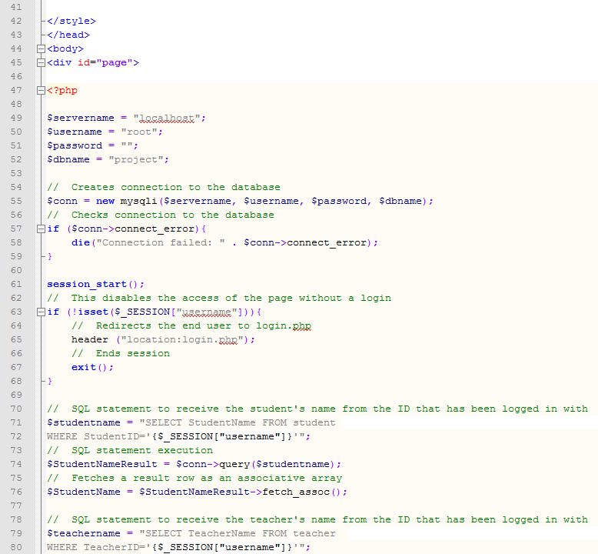

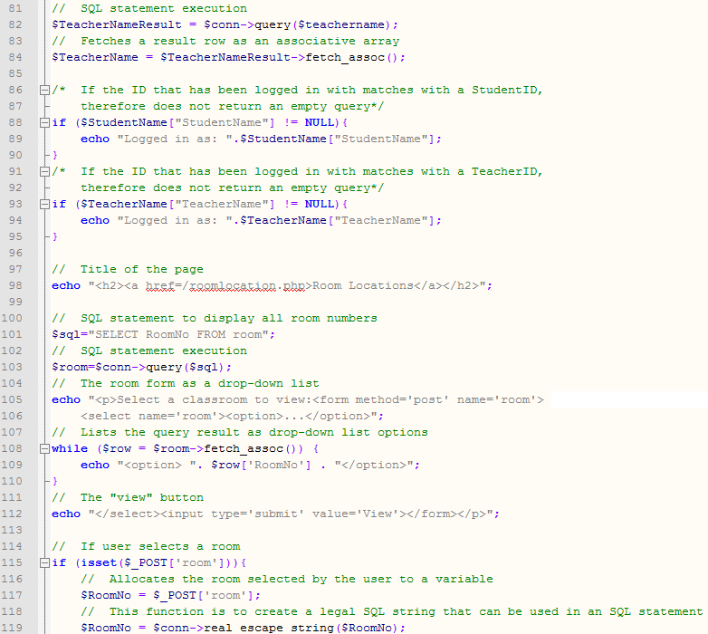

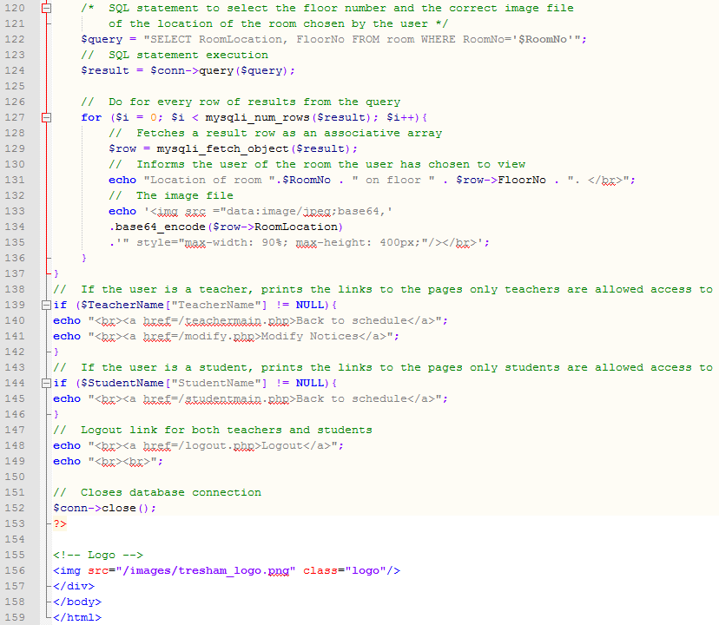

Modify.php

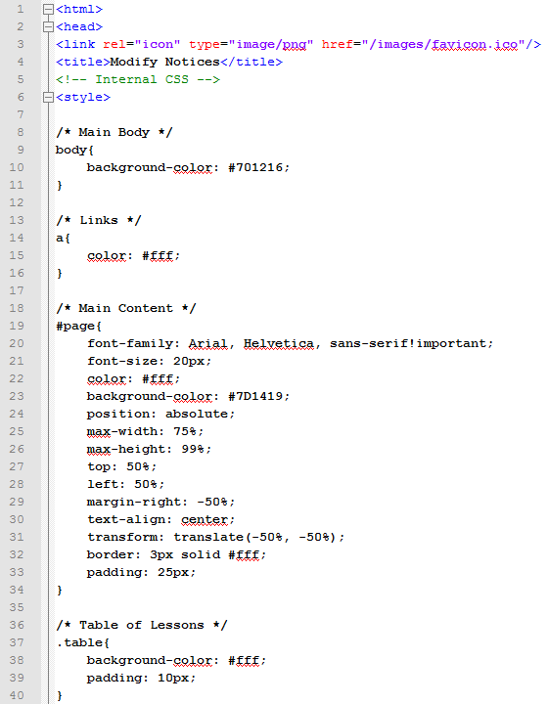

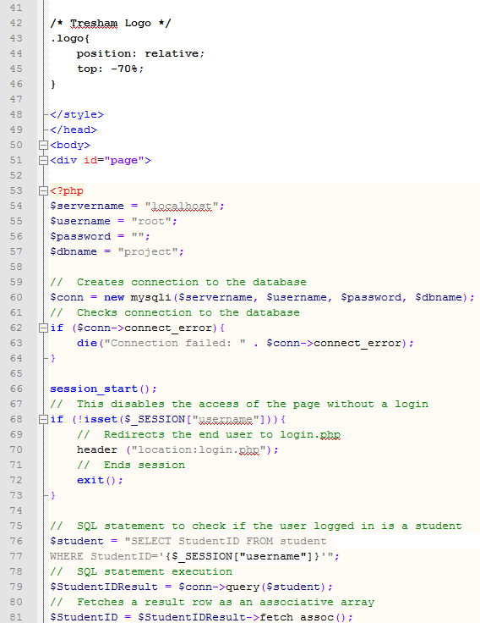

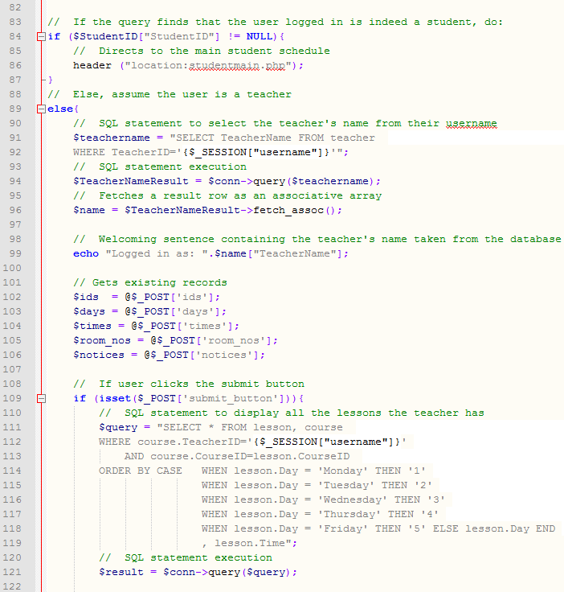

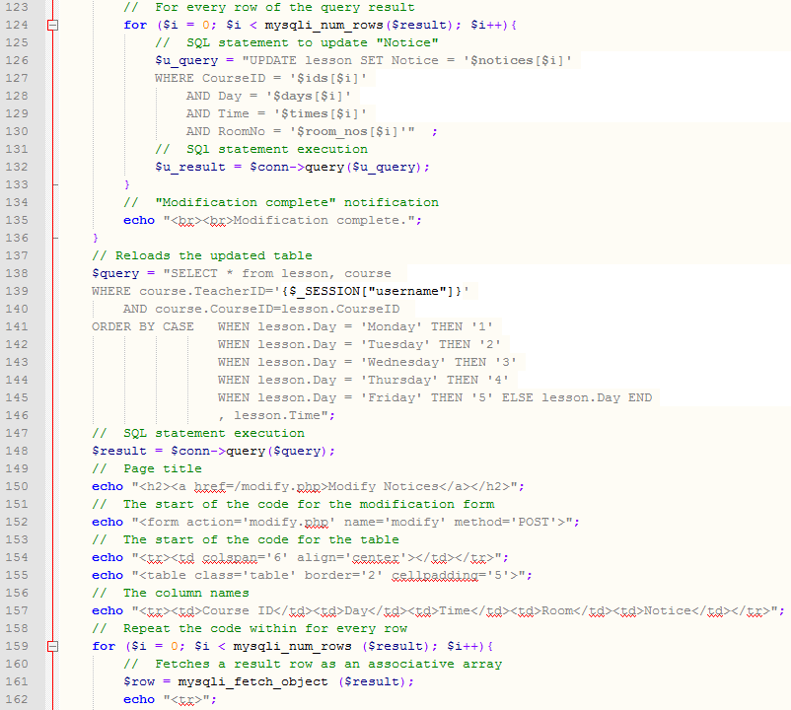

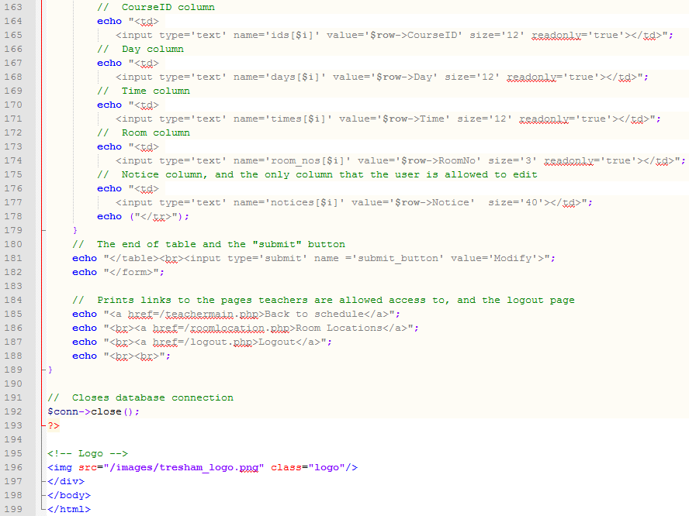

Logout.php

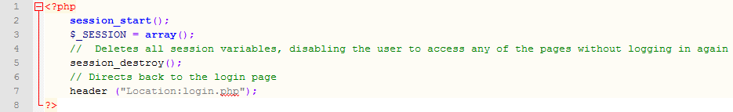

# Testing

## Alpha testing plans

### *Input and output*

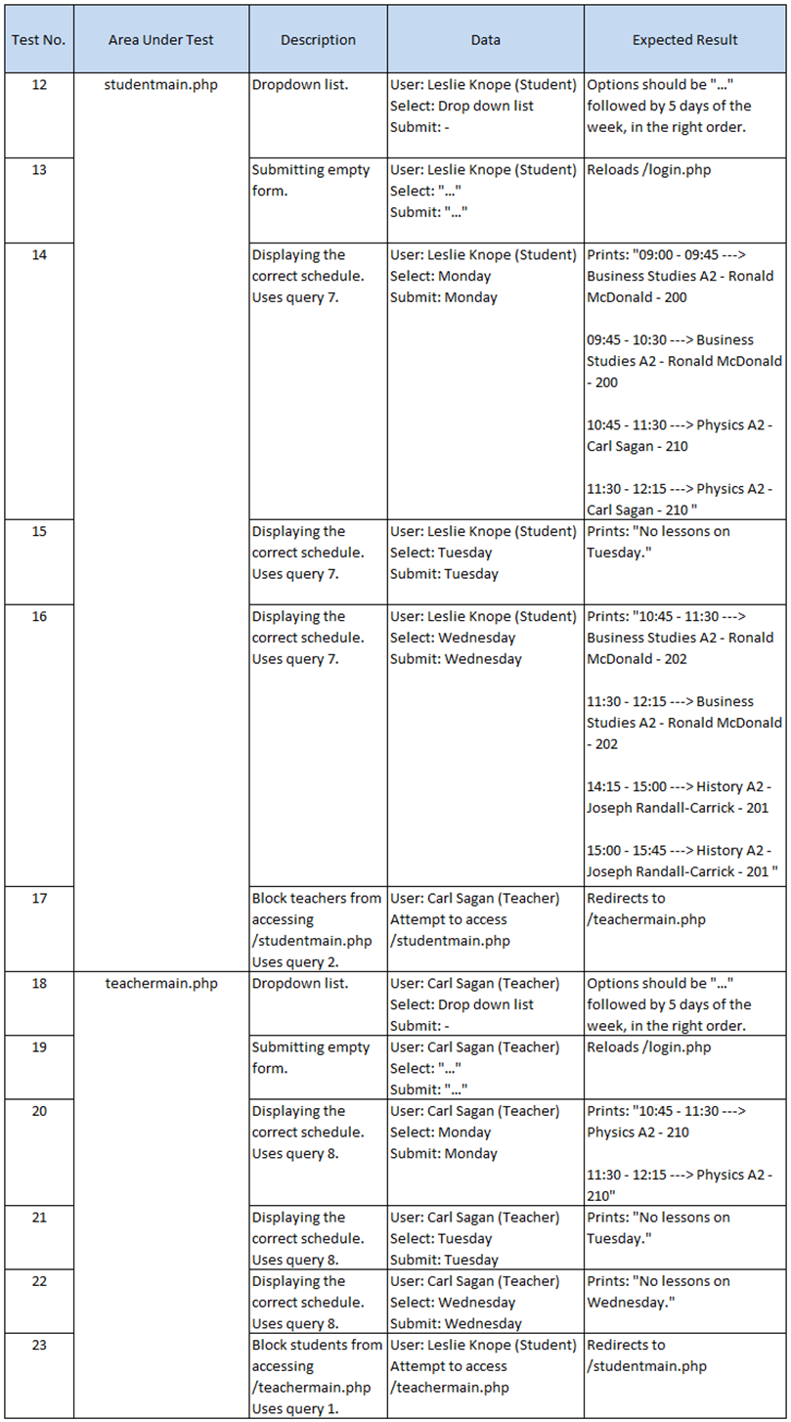

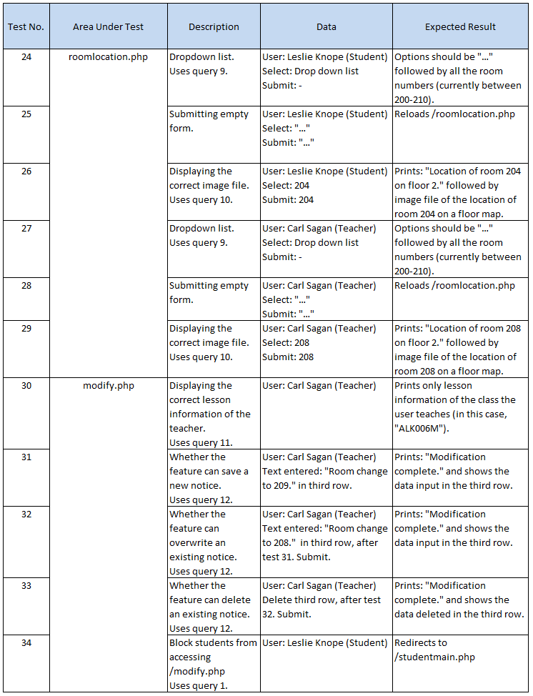

### *Links*

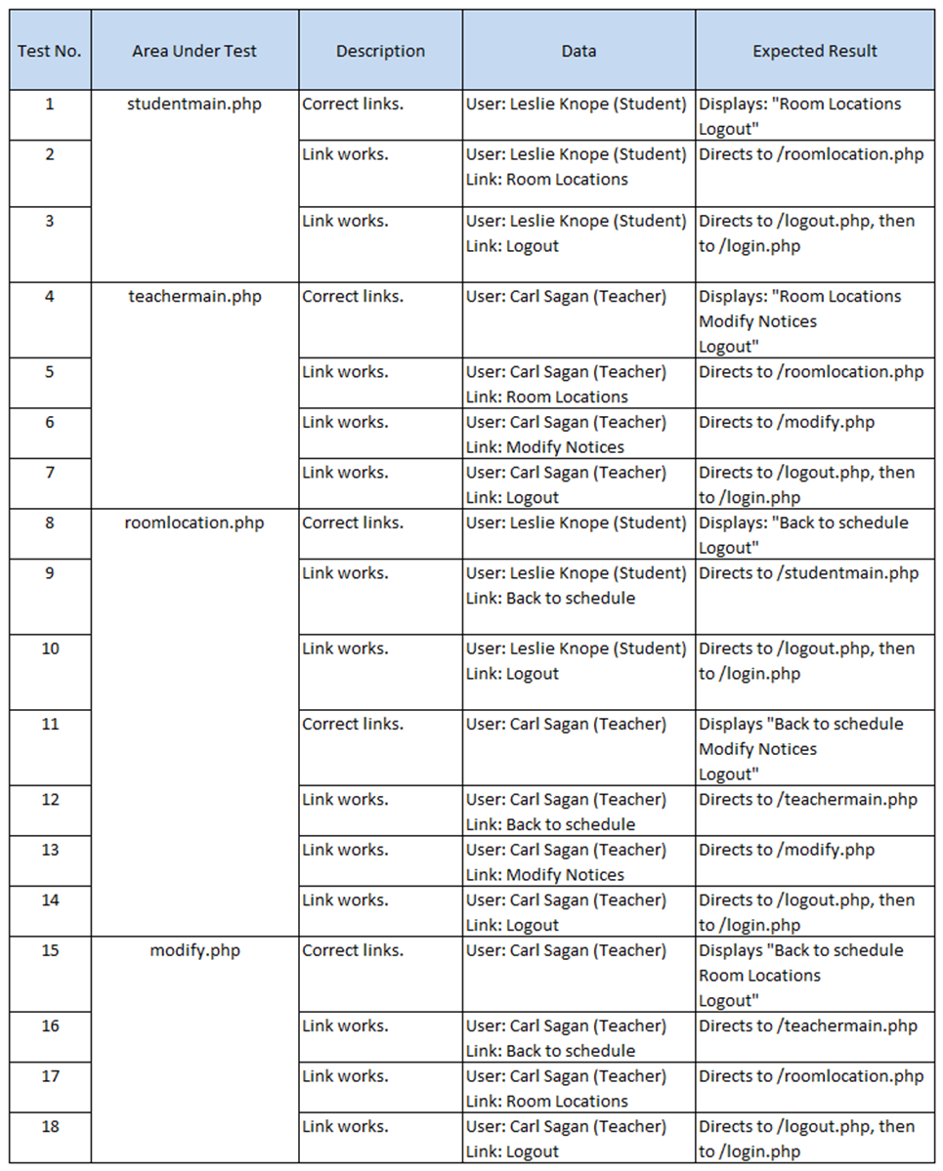

### *Form*

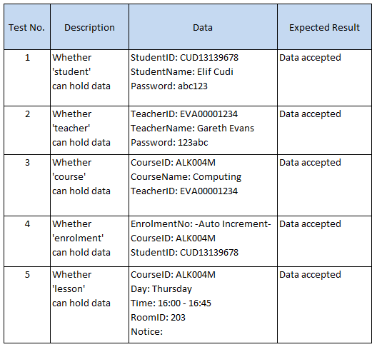

There is no test for whether ‘room’ can hold data because the room numbers are definite, and cannot be changed.

## Alpha testing

The numbers in the “Actual Result” column are the reference numbers for the screenshots of the test outcomes. These screenshots can be found in section 6.2.4

### *Input and output*

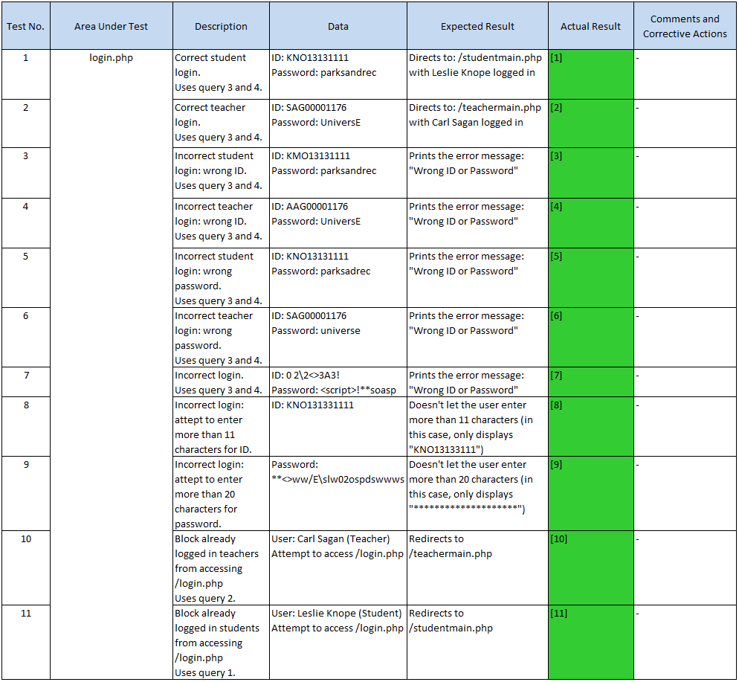

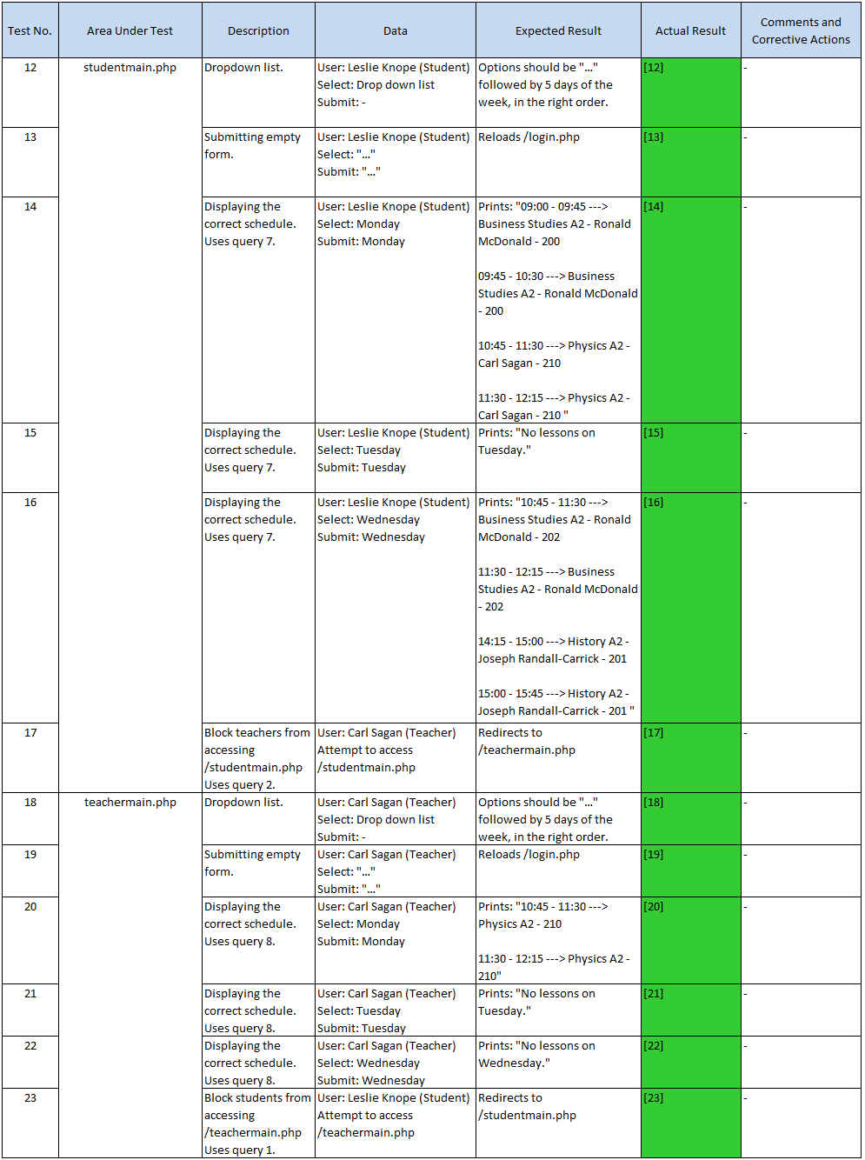

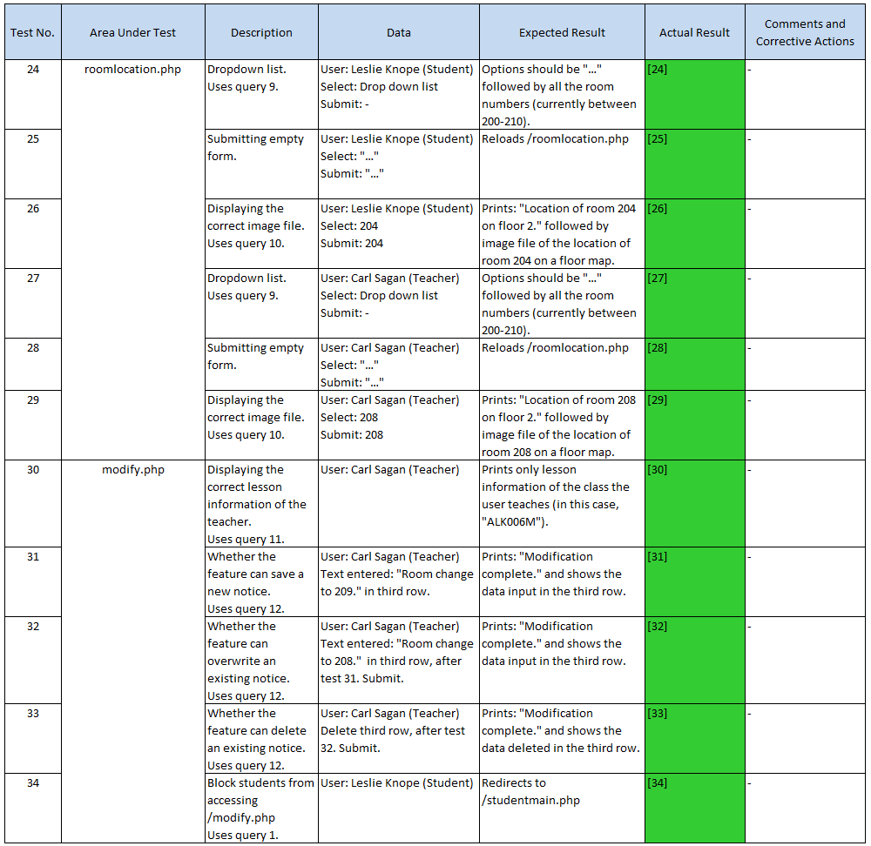

### *Links*

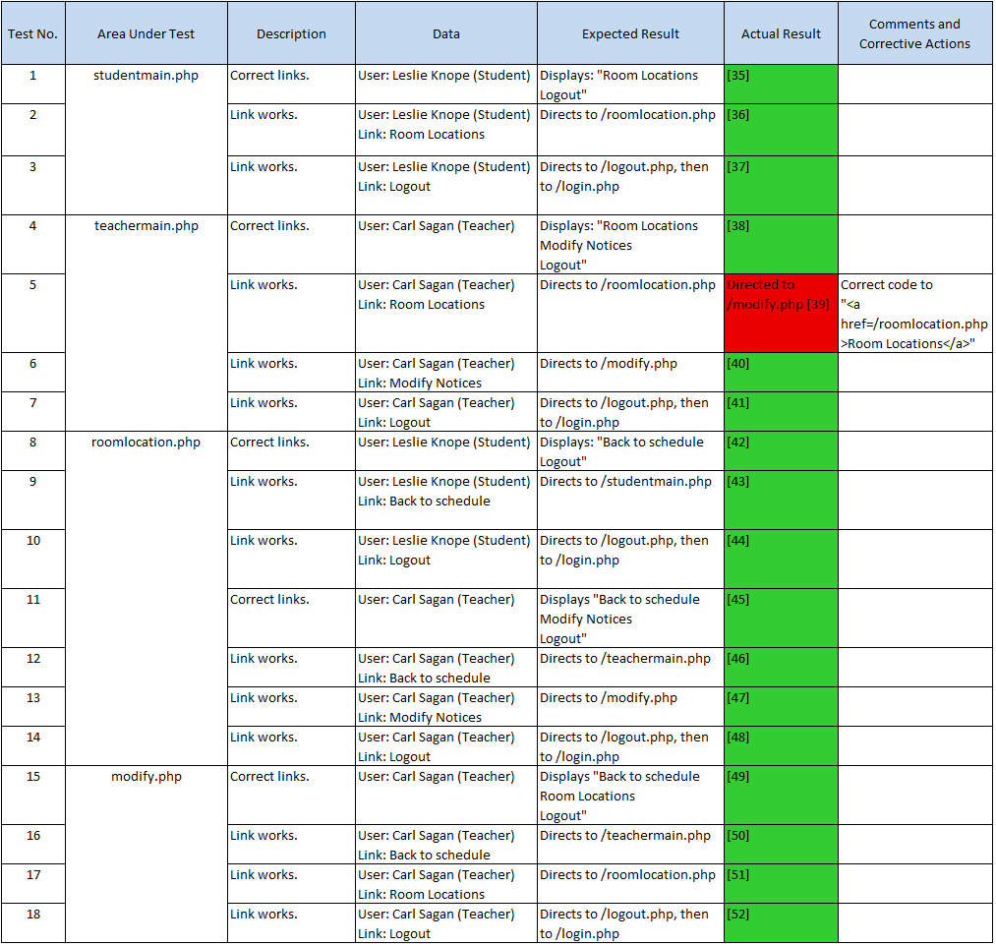

### *Form*

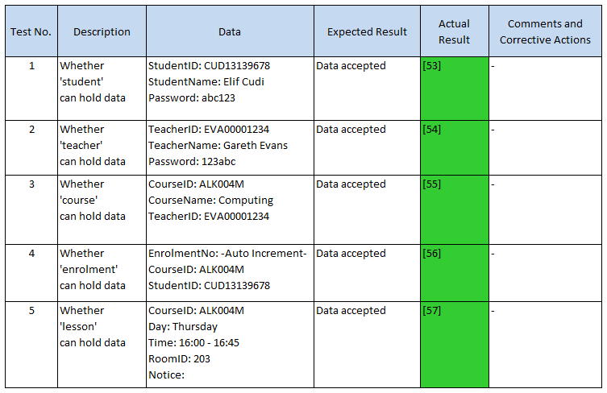

### *Testing Outcome Screenshots*

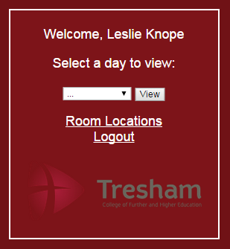  
**[1]**

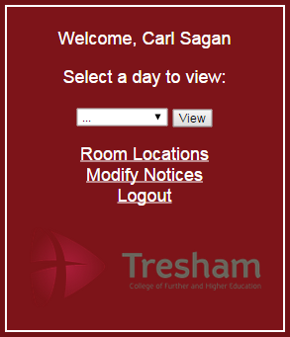**[2]**

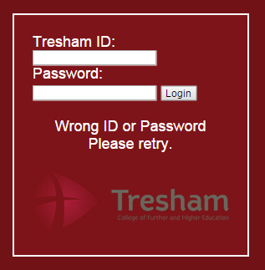**[3]**

**[4]**

**[5]**

**[6]**

**[7]**

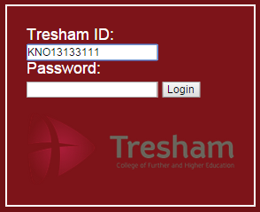

**[8]**

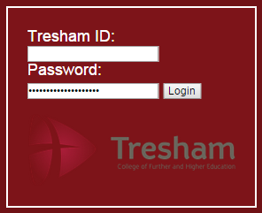**[9]**

  
  
  
**[10]**



**[11]**

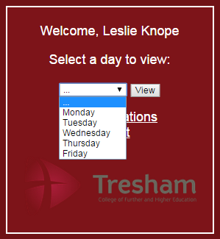**[12]**

  
**[13]**

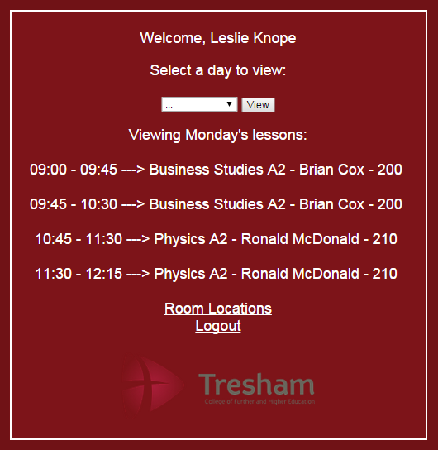

**[14]**

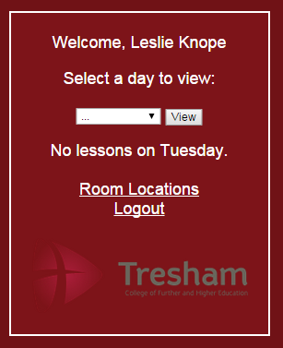**[15]**

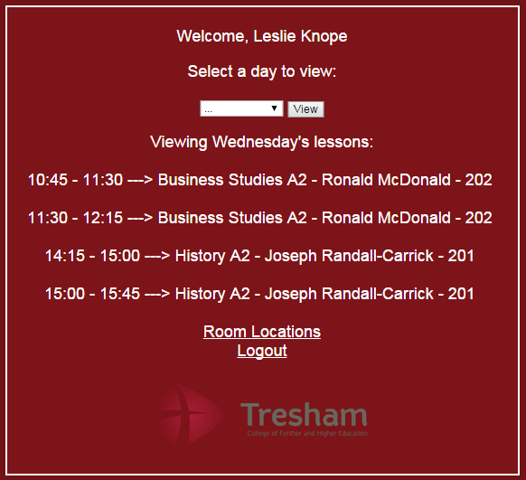

**[16]**



**[17]**

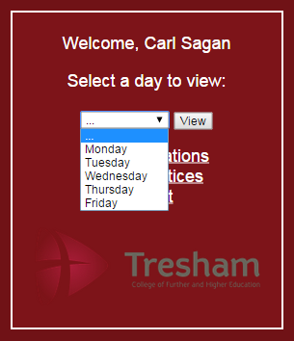**[18]**

  
**[19]**

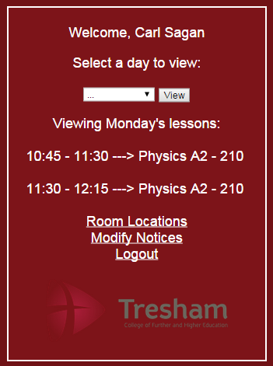  
**[20]**

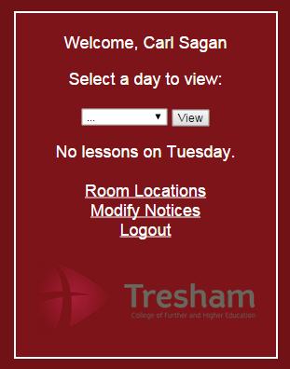**[21]**

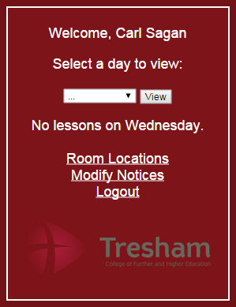**[22]**



**[23]**

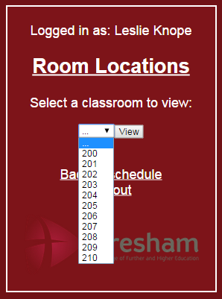**[24]**

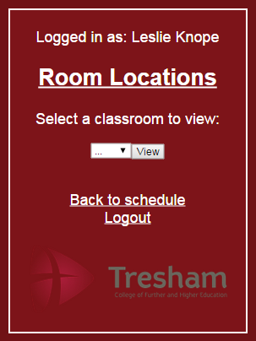**[25]**

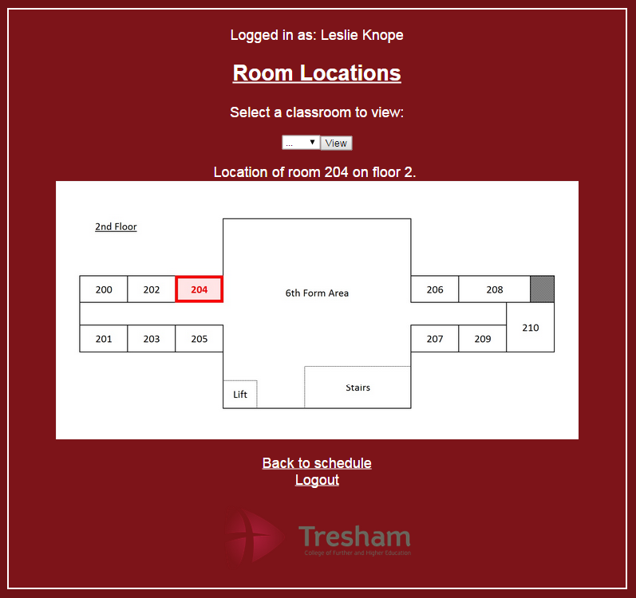**[26]**

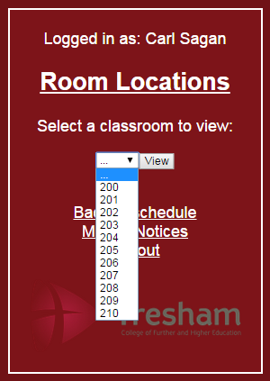**[27]**

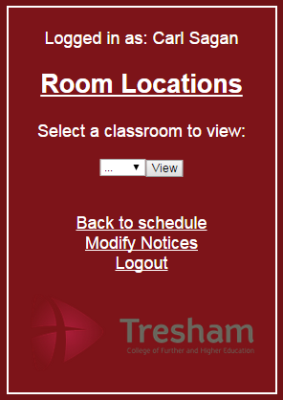**[28]**

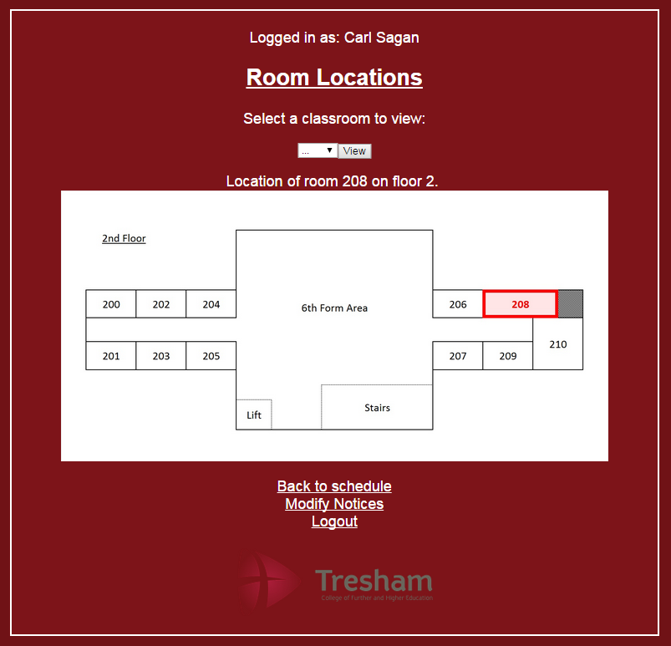

**[29]**

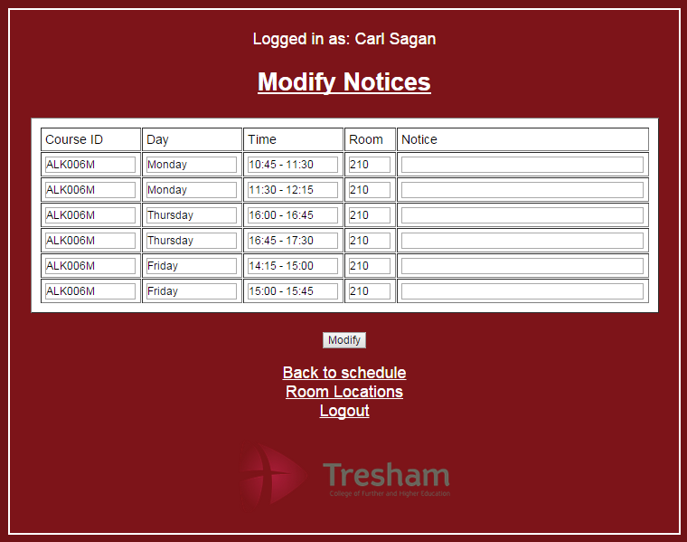**[30]**

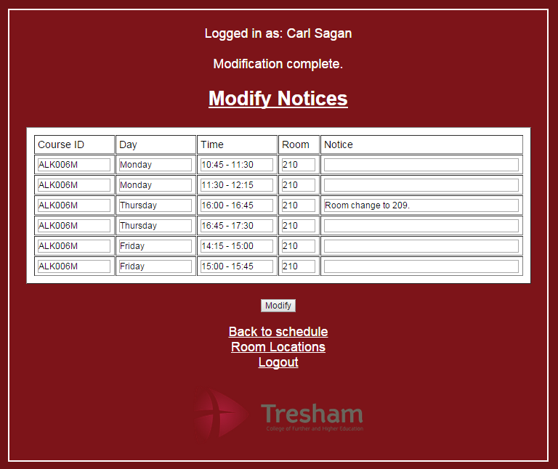

**[31]**

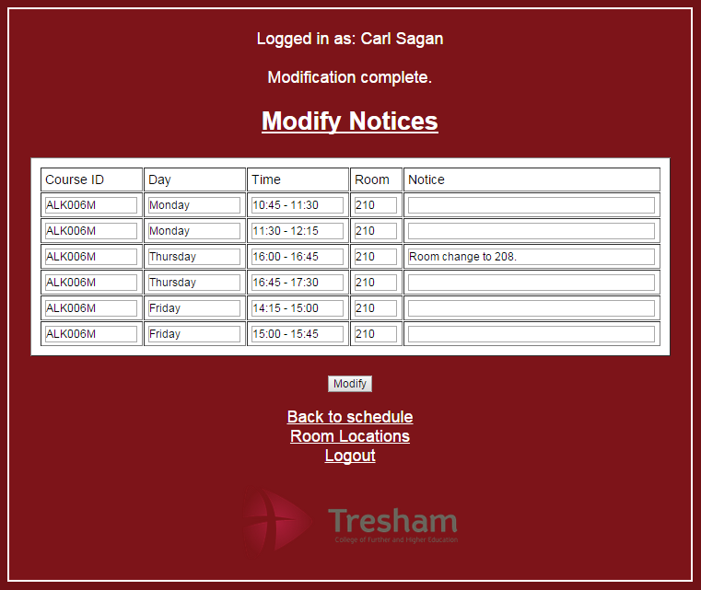**[32]**

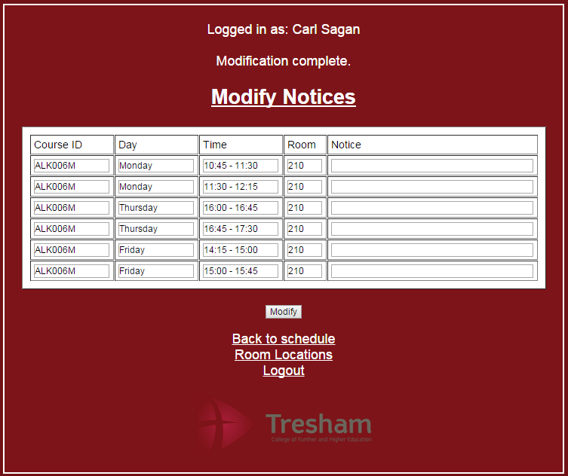

**[33]**

**[34]**



**[35]**

**[36]**

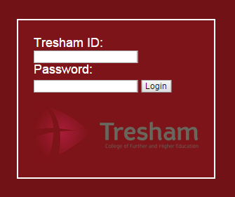

**[37]**



**[38]**

**[39] Faulty   
Result**



**[39] Corrected   
  
Result**

**[40]**



**[41]**



**[42]**

**[43]**



**[44]**



**[45]**

**[46]**

  
**[47]**



**[48]**

**[49]**



**[50]**

**[51]**

**[52]**

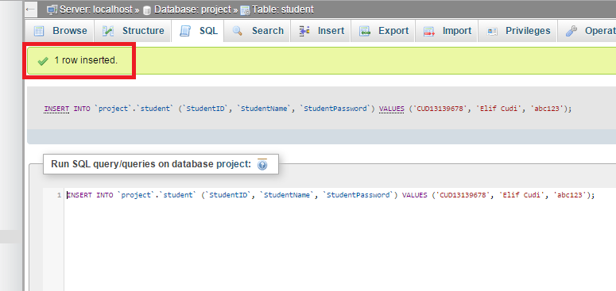**[53]**

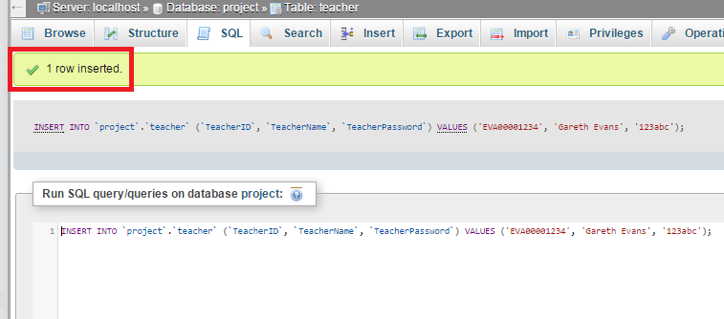

**[54]**

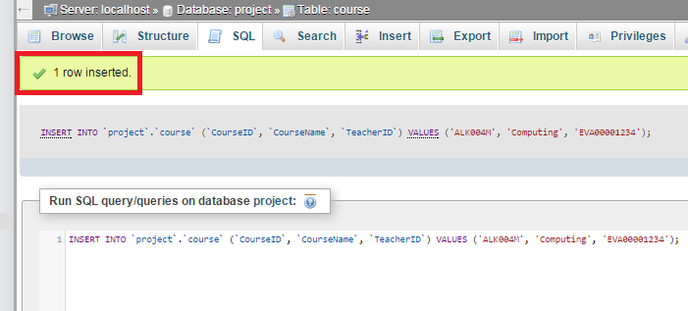**[55]**

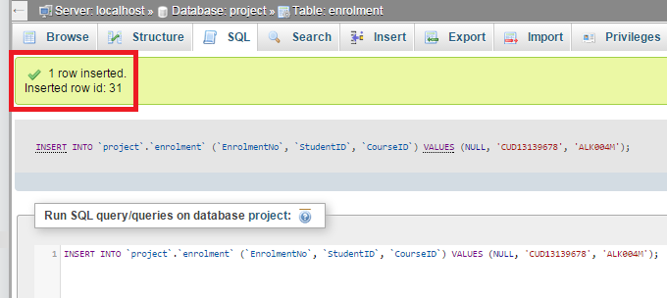**[56]**

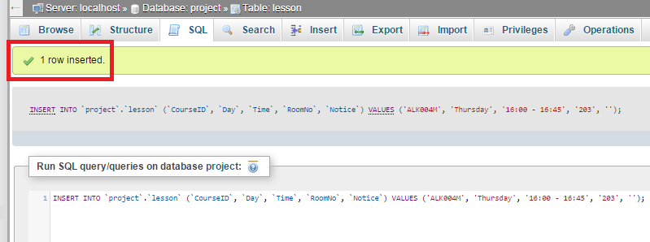

**[57]**

## Beta testing plans

### *Student UI*

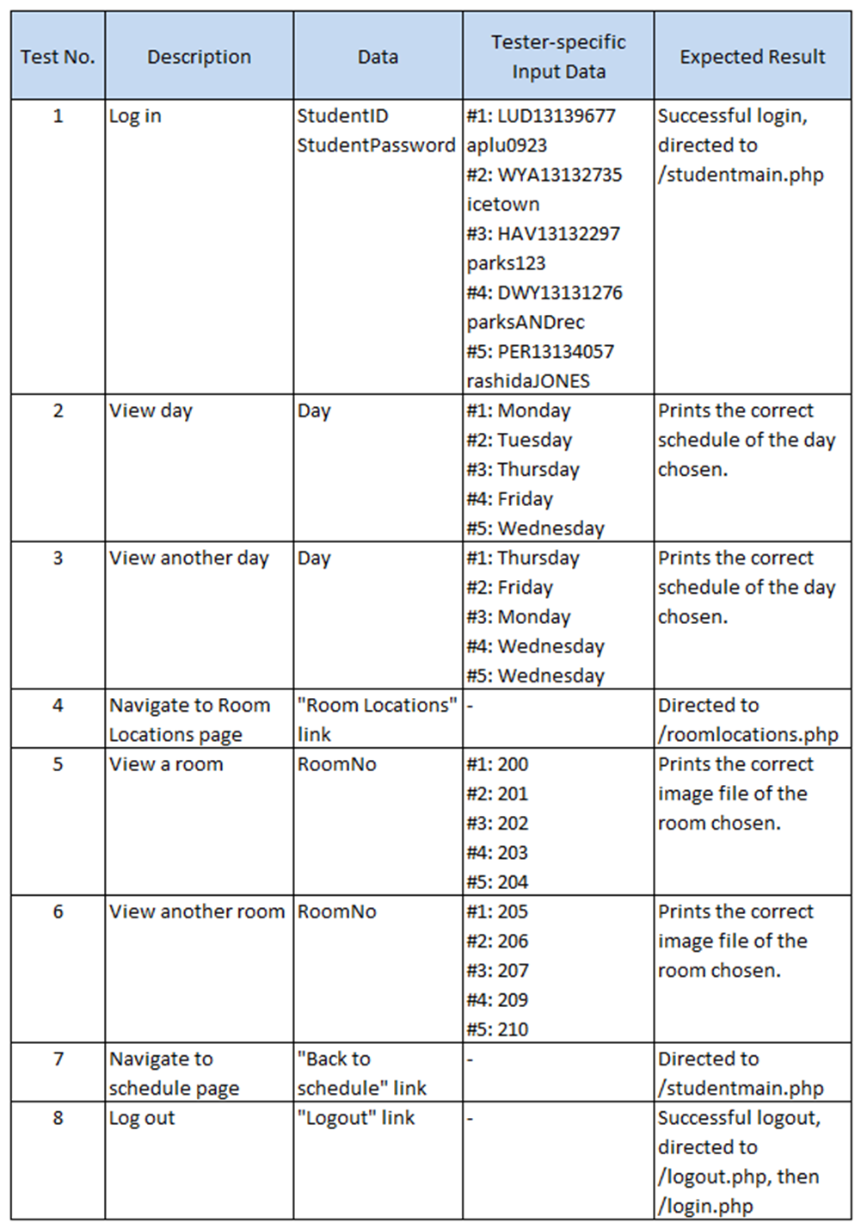

### *Teacher UI*

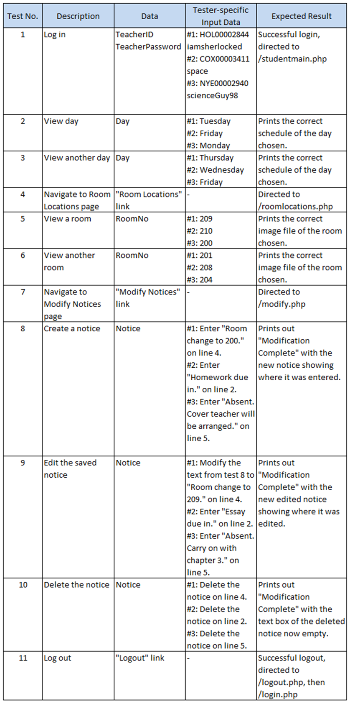

## Beta testing

### *Student UI*

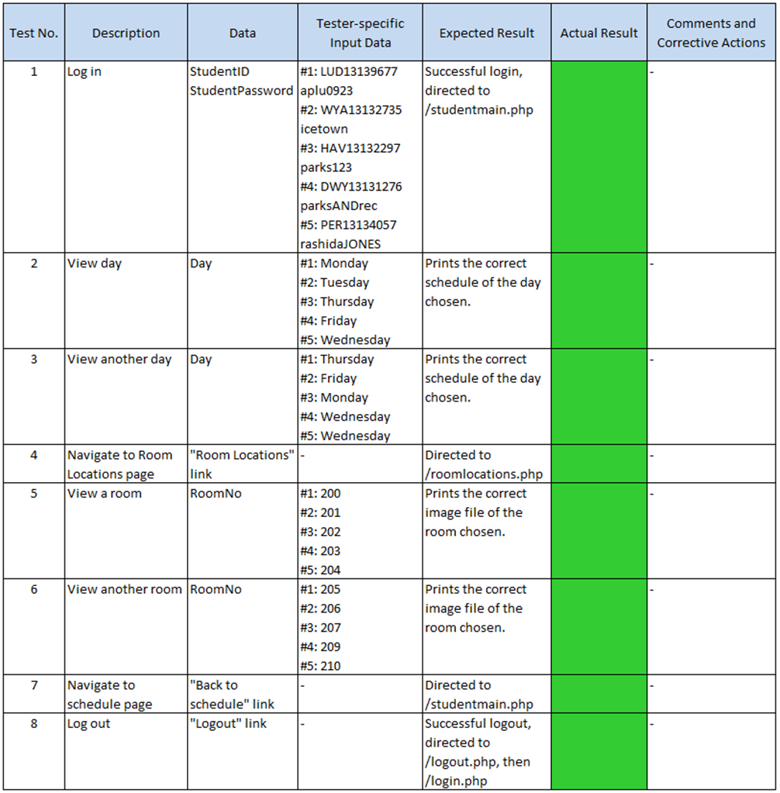

### *Teacher UI*

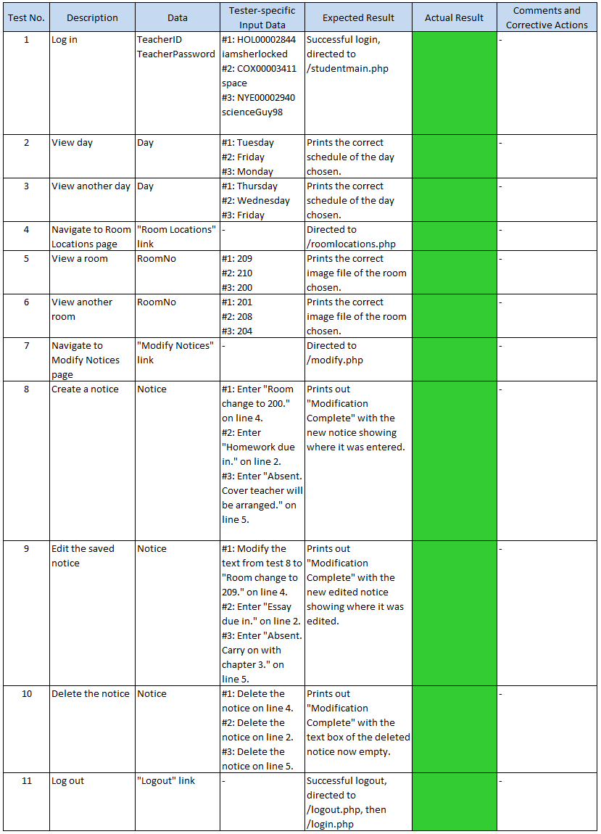

# Documentation

## User Manual

**[Separate Document]**

# Evaluation

## Comparison of Project Performance against Objectives

The following table compares the performance of the completed system to the objective originally set in section 1.2

Key:

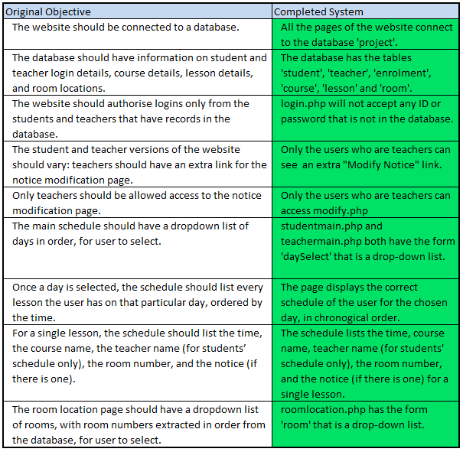

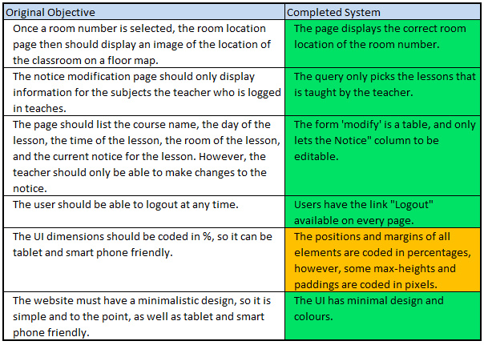

## Future Development

Mobile app – This system has a great potential for being developed as a mobile application. The app could have a similar UI as the website, but some extra features would be:

* Users receiving notifications when teachers create new notices (this would include any modifications), lesson reminders, and maybe even a notification in the morning showing that day’s entire schedule.
* A mini navigation feature for students to locate classrooms. It could navigate users from a specific point in the building to the desired classroom.
* An instant messaging service between the users of the system.

Improving the notice page – I believe the current UI for the notice page looks bland and too much information is being shown. Future improvements could be:

* To highlight the “Notice” column, so the teachers know that the “Notice” column is the only column they can edit.
* Have two drop-down lists (both unique to the teacher and the lessons they teach) instead of a table: one for the day and the other for the time. Teachers could select the lesson they want to add a notice to, rather than finding it on a table.

The flaw with the Notices – At Tresham, a single lesson slot is given as 45 minutes; therefore this led me to count a single lesson as 45 minutes on the database. However, in A Levels, most lessons are doubles, with some even being triples. This complication is currently causing the teachers to enter on the system, the same notice multiple times to the double/triple lessons they have. They have the option of just updating the notice on the first 45 minute slot of the double/triple lesson, but I would rather fix this problem and enable to count a teachers double/triple lesson as a one single lesson in the future using javascript.

Expanding the system – The prototype is designed only for the A2 students of the Kettering campus of Tresham. The system could be expanded to include all courses offered by the college, and eventually be available for students and teachers of all three campuses of Tresham.

Whole timetable – Currently this system is only a daily schedule. However, it can be developed into showing the user’s weekly timetable. The notices would show as pins on each lesson, which when scrolled over or clicked on could display a text box to showing the notice.

## User Feedback

I have used surveymonkey.com to create the user feedback form. I set up the prototype on a computer for 5 students and 3 teachers. I then gave them logins, and the user manual to help them navigate through the website.

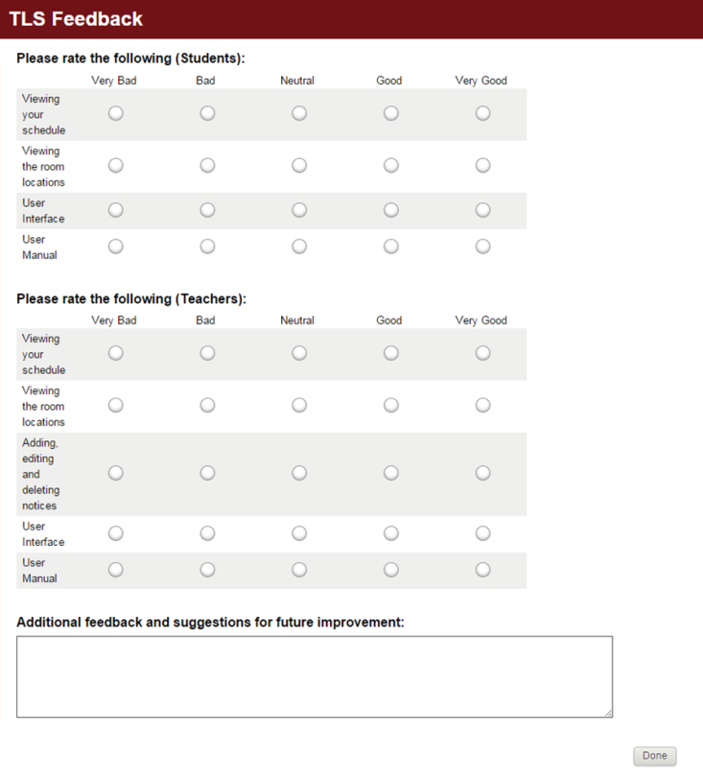The feedback form:

Student Feedback:

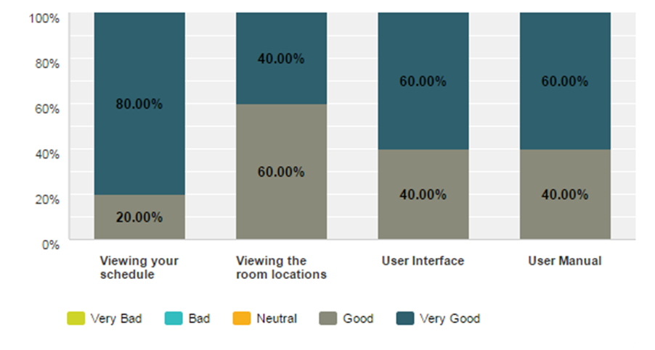

Additional feedback (2 received out of 5 students):

* Maybe make it so that the current notices are constantly displayed.
* Use a better font and improve the overall design, like change the background from Burgundy to a more appealing colour.

Teacher Feedback:

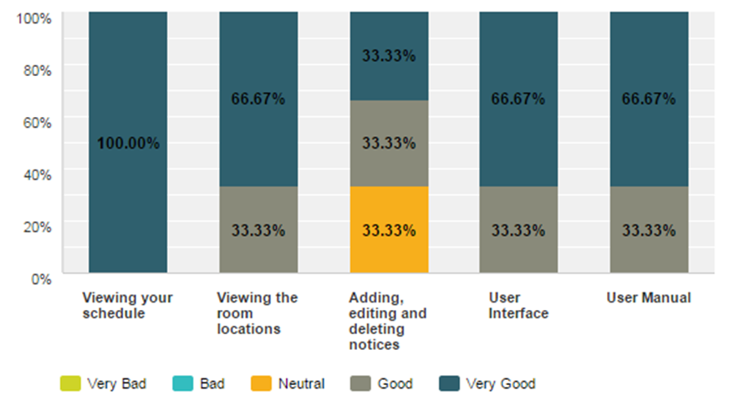

Additional feedback (3 received out of 3 teachers):

* I didn't like the look of the Modify Notices page. I think it would be better if the Notice column was highlighted somehow. Also, the "Modification Complete" message is barely noticeable after the first edit. Either a pop-up box asking to confirm submission or a pop-up box confirming submission would be better. Other than that, I found this system very useful to quickly check my schedule and notify students of any changes.
* This is such a wonderful way to connect with the students on a very simple level. We really are in need of a system like this.
* The "modification complete" message wasn't noticeable at first, and it would be better if the room locations were somehow incorporated with the schedule. Otherwise, everything works smoothly and it is to the point. In the future I would love to see a full timetable option instead of a single day's schedule.

Analysis of feedback

The system overall seems to be user friendly, with most answers being between the ‘Good’ and ‘Very Good’ options. The adding, editing and deleting notices section for teachers have achieved a more diverse response, because the teachers the survey was given to have mostly said they had a difficulty understanding whether they have modified a notice or not. This shows that for the updated release of the system a pop-up box is a must.

One of the students has recommended constantly displaying notices. This can be made possible by adding a box of notices at the bottom of every page, or having all the current notices pop up as a starter page after the user has logged in.